CyberSourceCartridge
Version 2.1.3


06/20/2014

Contents
Summary 5
Component Overview 7
Functional Overview 7
Credit Card Authorization Service 7
Taxes 8
Address Verification Service (AVS) 9
Delivery Address Verification Service (DAV) 9
Bill Me Later (BML) 9
Decision Manager 10
Payment Tokenization 12
Payer Authentication 12
Full Authorization Reversal 13
V.me by Visa 13
Retail Point-of-Sale (POS) 14
Use Cases Scenarios 15
Credit Card Authorization 15
Taxes 17
Address Validation Service (AVS) 18
Delivery Address Verification Service (DAV) 18
BML 19
Decision Manager 19
Payment Tokenization 20
Payer Authorization 20
V.me by Visa 21
Retail Point-of-Sale (POS) 25
Limitations, Constraints 26
Compatibility 26
Implementation Guide 27
➢ Before Integration 27
Custom Code 28
Credit Card Auth 28
Bill Me Later 33
Tax Service 34
Address Verification Service 37
Delivery Address Validation Service 37
Full Authorization Reversal 38
Payer Authentication Service 38
Payment Tokenization Service 39
V.me by Visa 57
Clickjacking Prevention 71
Order Export XML – New Fields 73
Retail POS 75
Site Configuration 84
Import Meta Data 84
Configure Site Preferences 85
Configure Site Preferences for V.me 90
Applying CyberSource Cartridge to the Site 90
Applying V.me Cartridge to the Site 91
Configure Custom Objects for Retail POS 92
Testing 94
Authorize Credit Card 94
Tax Service 94
Address Verification Service (AVS) 94
Delivery Address Verification Service (DAV) 94
Payment Tokenization 95
Full Authorization reversal 95
Device Fingerprint 95
Payer Authentication 95
V.me Authorization 95
V.me Get Checkout Details 95
V.me Confirm Purchase 96
V.me Authorization Reversal 96
V.me Capture 96
V.me Refund 96
V.me Initiate Request 96
Retail POS Authorization Request 96
Cartridges Structure and Reference 97
Pipelines 97
Scripts 97
Templates 99
Configuration Files 99
V.me Cartridge Structure 99
Retail POS Cartridge Components 100
Typical Project Plan 101
Roles, Responsibilities 101
Typical Efforts and Timelines 101
Pre Production Steps 103
CyberSource Site Preferences 105
V.me Site Preferences 107
Device Fingerprint 109
How does it work? 109
Setup: 109
Hints for the CsDeviceFingerprintRedirectionType: 110
Modified Scripts and pipelines for the device fingerprint 111
Known Issues 112
CyberSource document links 113
Release History 114

Summary
This document provides technical overview and implementation details for each CyberSource service integrated within Demandware platform. The CyberSource cartridge extends the functionality of Demandware Storefront, enabling real time access to CyberSource eCommerce transaction services listed below.

Credit Card Authorization – The CyberSource Credit Card Authorization service provides merchant with a mechanism to get authorization for the order amount. The authorization service validates the card based and authorize card for the order amount. For additional spam/fraud detection by Cybersource, a ‘device fingerprint’ could be submitted additionally, if configured.

CyberSource Address Verification (AVS) – The CyberSource AVS service provides merchants with a mechanism to reduce merchant banking fees, by verifying billing information before authorizing payment for customer purchases. Although the AVS service is automatically called during the authorization process, the behavior resulting from specific AVS responses and its interaction with the payment process is customizable through storefront configuration.

Tax Service – The CyberSource tax calculation service provides merchants with a complete tax calculation service according to and pursuant to domestic and international tax regulations, including but not limited to, district, city, county and state levels of governing tax authority.

Delivery Address Verification (DAV) Service – The CyberSource DAV service provides merchants with an optional mechanism to prevent, limit or correct faulty shipping information, related to improperly entered or formatted information from the customer. This service helps reduce the potential additional costs resulting from undeliverable or returned merchandise.

Bill Me Later Service – The Bill Me Later service from Bill Me Later, Inc., and available via your single connection to CyberSource, allows your customers to make purchases using an instant line of credit.
Decision Manager – CyberSource Decision Manager Service provides set of tools that merchant to evaluate rules and chose tool and return a decision of “Accept”, “Reject”, or “Review”. Merchant can also setup process to ignore certain rules when necessary.

Payment Tokenization – CyberSource Payment Tokenization Service provides set of tools to store customer and payment related sensitive data on secured cybersource hosted servers.

Payer Authentication – CyberSource Payer Authentication services enable you to add support to your web store for card authentication services, including Visa Verified by VisaSM, MasterCard® andMaestro® SecureCode™ (UK Domestic and international), American Express SafeKeySM.

V.me by Visa – V.me service by Visa is a service that lets customers easily checkout without entering their payment information. V.me simplifies the payment experience for customers. Merchants can add the V.me checkout button to their site, so customers can check out with a user name and password. Customers store their major credit or debit cards (Visa, MasterCard, American Express, Discover) and shipping addresses in their V.me account. To pay, customers click the V.me checkout button and sign into their account. They confirm their payment details and complete checkout in just a few clicks without leaving merchant’s site.

Component Overview

Functional Overview

Credit Card Authorization Service

The credit card authorization service pipeline allows storefront application to request for credit authorization for the total order amount. The pipeline makes the credit card authorization web service call to CyberSource authorization service and receive confirmation about the availability of the funds.
The Demandware Cybersource–AuthorizeCreditCard pipeline populates the authorization request with ship-to, bill-to, credit card data, and purchase total data from the basket and invokes the authorization web service call using CyberSource web service API.
Credit Card Authorization sequence flow:
- Creates CyberSource authorization request using ship-to, bill-to, credit card data, and purchase total data from the current basket.
- If authorize Payer is configured, then make the authorize payer request, if not ignore and continue with the authorization request.
- Create credit card authorization request.
- If DAV is enabled, then set up DAV business rules, as needed.
- Set up AVS Ignore Result business rule for request with AVS Ignore Flags specification, as needed.
- Make actual service call to CyberSource Simple Order API.
- If Delivery Address Verification is enabled, then:
  - Capture pertinent DAV result information & DAV Reason Code
  - If DAV fails and DAV On Failure is set to ‘REJECT’, then exit immediately with rejection response
- If DAV On Failure is set to ‘APPROVE’ and the DAV Reason Code is a fail code (not 100), then:
  - Exit immediately with declined or review response, as merchant defines
- Capture pertinent AVS information
- Validate authorization reason code and set corresponding end node, based on auth response code.

The list of activities depicted in the following diagram take place when API request is made for an online credit card authorization: [Source, CyberSource Credit Card Service, October 2009]
Figure 1 Processing an Online Authorization [Source, CyberSource Credit Card Service, October 2009]
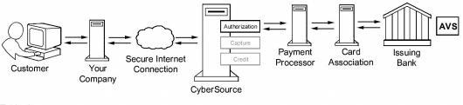
- The customer places an order and provides the credit card number, the card expiration date, and other information about the card.
2 You send a request for authorization over a secure Internet connection. If the customer buys a digitally delivered product or service, you can request both the authorization and the capture at the same time. If the customer buys a physically fulfilled product, do not request the capture until you ship the product.
3 CyberSource validates the order information, then contacts your payment processor and requests authorization.
4 The processor sends the transaction to the card association, which routes it to the issuing bank for the customer’s credit card. Some card companies, including Discover and American Express, act as their own issuing banks.
5 The issuing bank approves or declines the request. Depending on the card type, the bank could also use the Address Verification Service (AVS) to determine whether the customer provided the correct billing address. For more information about AVS, refer to AVS service documents via the CyberSource Services Documentation at http://www.cybersource.com/support_center/support_documentation/services_documentation/payment.php or as described in this integration guide.
6 CyberSource runs its own tests, then tells you if the authorization succeeded.
7 Response is sent back to the client.

Taxes
Online Customer adds Product(s) to Cart and proceeds to Checkout.
As soon as shipping information is entered and validated, taxes are updated to reflect current tax rates based on six basic criteria:
- Customer ship to address
- Merchant ship from address
- Merchant point of order origin (POO)
- Merchant point of order acceptance (POA)
- Product code
- Merchant nexus

Product information is provided on an individual line item basis and all merchant/request IDs are captured for future reference. When the customer enters in shipping information, the Tax Service is called to calculate taxes.

Address Verification Service (AVS)
AVS does not exist as a stand-alone callable service. Please refer to the Credit Card Authorization Service walkthrough for high level walkthrough.

Delivery Address Verification Service (DAV)
DAV service may be run as a stand-alone callable service, as well as be performed as a part of other services. Please refer to Credit Card Authorization Service for more information regarding the DAV service, as an integral part of payment auth.
As a stand-alone service, the process is defined as:
- Customer enters shipping information
- Shipping information passes client-side validation (required elements filled in)
- Shipping information passes basic server-side validation (syntactically correct)
- Request is made to CyberSource DAV Service
- Response returns DAVReasonCode (100=Success)
- End node returns either: authorized, declined or error (authorized==success, declined==failure)
- Captured validation information is extracted from pipeline dictionary to present user with choices to correct problems, confirm “standardized” formatting or try again
- If service is successful, allow ShippingAddress save operation to continue

Bill Me Later (BML)
A customer selects Bill Me Later during the checkout process at your site, similar to selecting the option to pay via Visa or MasterCard.
To request a Bill Me Later authorization, Demandware pipeline sends a request for a credit card authorization but instead of including a credit card number in the request, send the customer’s Bill Me Later account number set in the custom preferences.
To bill the customer, send a request for a credit card capture. No additional capture request fields are required for a Bill Me Later capture, unless you are processing multiple captures.
The Bill Me Later authorization service pipeline allows storefront application to request for credit authorization for the total order amount through the Bill Me Later.
The Demandware Cybersource–AuthorizeBML pipeline populates the authorization request with ship-to, bill-to, credit card data, and purchase total data from the basket and invokes the authorization web service call using CyberSource web service API.
Bill Me Later authorization sequence process:
- If it is the first time a customer has used Bill Me Later, they are presented with terms and conditions and asked for date of birth and last 4 digits of social security number.
- Once terms are agreed to, checkout continues as usual.
- A real-time credit decision is made and the consumer is notified within 3-5 seconds.
- On subsequent purchases, the customer simply chooses Bill Me Later, a real-time credit decision is made and the customer is notified within 3-5 seconds.
- In rare circumstances, additional verification steps are applied.
- After completion of the first purchase a welcome email is sent by Bill Me Later. This email contains a secure link for login to the self-service website, as well as a user ID for the customer.
- Your customer typically receives a bill (sent by Bill Me Later, Inc.) in their mailbox within fifteen days of the settlement posting to the customer’s account. The due date for this bill is 25 days from the date the bill is rendered.
- You submit the transaction for settlement upon shipment of goods or rendering the service—just as you do with a credit card purchase. Funding is received within the same timeframe as that of a purchase made with a credit card.

Decision Manager
The CyberSoruce Decision Manager provides Merchant and ability to set business rules, provide case management, and Reporting.
The CyberSource Decision Manager Business rule engine allows Merchant to analyze the order data based on predefined or custom rules. The business rules can be set by orders, by category, or by SKU. The
The Demandware CyberSource Cartridge pipeline processes incoming Decision Manager Request and set contained orders to the new decision made through the decision manager.
NOTE: Make the pipeline Cybersource-NewDecision as public before using in production environment.

Entry point into Demandware pipeline:
http://<sandboxname>/on/demandware.store/Sites-<store>-Site/default/Cybersource-NewDecision?content=<xml content>

Sample incoming reviewed order status update xml file

<?xml%20version=”1.0”%20encoding=”utf-8”?>
<!DOCTYPECaseManagementOrderStatus SYSTEM “https://ebctest.cybersource.com/ebctest/reports/dtd/cmorderstatus_1_1.dtd”>
<CaseManagementOrderStatus
MerchantID=”sample_merchant”
Name=”Case Management Order Status”
Date=”2008-12-18 12:22:09 GMT”
Version=”1.1”
nxmlns=”http://reports.cybersource.com/reports/cmos/1.0”>
<Update MerchantReferenceNumber=”10679256010963322294714”RequestID=”1744185012770167904567”>
<OriginalDecision>REVIEW</OriginalDecision>
<NewDecision>ACCEPT</NewDecision>
<Reviewer>sample_reviewer</Reviewer>
<ReviewerComments>sample_comment</ReviewerComments>
<Queue>sample_queue</Queue>
<Profile>test</Profile>
<FollowonResult>
<Status>Success</Status>
<Application>Credit%20Card%20Settlement</Application>
<RequestID>1744185012770167904567</RequestID>
<Decision>Accept</Decision>
<ReasonCode>100</ReasonCode>
<Rcode>1</Rcode>
<Rflag>SOK</Rflag>
<RMsg>Request%20was%20processed%20successfully.</RMsg>
</FollowonResult>
</Update>
</CaseManagementOrderStatus>

Payment Tokenization
Tokenization is the replacement of sensitive data with a unique identifier that cannot be mathematically reversed. In your environment, tokens take the place of sensitive credit card data. Typically, the token will retain the last four digits of the card as a means of accurately matching the token to the payment card owner. The remaining numbers are generated using proprietary tokenization algorithms.
How It Works
- To make a purchase on your website, the customer will enter their payment card information into the designated payment fields on the order page. These payment fields will be hosted by CyberSource using Hosted Payment Acceptance. When the customer hits the ‘submit’ button, the data is immediately encrypted and transmitted directly to CyberSource for storing, processing, and token generation. The payment data never enters your environment.
- The encrypted primary account number (PAN) is decrypted when it enters CyberSource’s Level 1, PCI-compliant data vault, where it is securely stored. The payment data is then passed on to the processing channel (bank) and returned to CyberSource with an accepted or denied result.
- CyberSource returns the result to you but substitutes the PAN data with a uniquely generated token. You store the token in your database of record system (such as ERP system) for future transactions or chargeback resolution on that account. Customer service representatives can easily verify customers as the custom token will retain the last four digits of the original PAN.

Payer Authentication
CyberSource Payer Authentication services enable you to add support to your web store for card authentication services, including Visa Verified by VisaSM, MasterCard® and Maestro® SecureCode™ (UK Domestic and international), American Express SafeKeySM, and JCB J/Secure™.
These card authentication services deter unauthorized card use and protect you from fraudulent chargeback activity referred to as liability shift.
How It Works
Payer Authentication provides the following services:
  - Check Enrollment: Determines whether the customer is enrolled in one of the card authentication programs.
  - Validate Authentication: Ensures that the authentication that you receive from the issuing bank is valid.
The Check Enrollment service determines whether the customer is enrolled in one of the
Card authentication services:
- No: If the card is not enrolled, you can process the authorization immediately.
- Yes: If the card is enrolled, the customer’s browser displays a window where the customer can enter the password associated with the card. This is how the customer authenticates their card with the issuing bank.
- If the password matches the password stored by the bank, you need to verify that the information is valid with the Validate Authentication service. If the identity of the sender is verified, you can process the payment with the Card Authorization service.
- If the password does not match the password stored by the bank, the customermay be fraudulent. You must refuse the card and can request another form ofpayment.

Full Authorization Reversal
A full authorization reversal is a follow-on transaction that uses the request ID returnedfrom a previousauthorization. The request IDlinks the full authorization reversal to theauthorization. CyberSource uses the request ID to look up the customer’s billing andaccount information from the original authorization, which means merchant is not required toinclude those fields in full authorization reversal request.

V.me by Visa

V.me by Visa cartridge for Demandware provides integration of Demandware merchant site with V.me Payment method.
CyberSource V.me Transaction Flow
Step 1 :Initiate Payment service request and reply—retrieves the apikey field and the signature
(token) field to be included in the v:init and v:buy tags.
Step 2 :V.me buy button functionality.
Step 3 :Get Checkout Details service request and reply—this service is optional and retrieves the
customers shipping information to calculate shipping and tax costs.
Step 4 : Confirm Purchase service request and reply—confirms the purchase total for the order.
Step 5 :Authorization service request and reply—reserves the funds on the customer’s account.
Step 6 :Capture service request and reply—captures the funds that were reserved by an
authorization service request.

Retail Point-of-Sale (POS)
This service of CyberSource enables a merchant to process a credit card for retail point-of-sale transaction at their stores. The integration takes inputs for the API service and provides CyberSource API response for later use. This integration takes care for terminal which has manual entry for credit card details and terminal with a magnetic stripe where a credit card can be swiped and enter amount for the transaction.

Use Cases Scenarios

Credit Card Authorization
The following table outlines the possible Demandware actions based on the response of the CyberSource gateway. Each client may choose to handle the response code differently. As of release 2.10, all errors logged as “fatal”, can activate an email alert to recipients identified in business manager.
Response | DW Storefront Action | Cyber-  Source  Code | CyberSource  suggested response
Successful transaction. | Continue Checkout | 100
Validation Errors
Request is missing one or more fields | Should not occur as validation should catch this  Show user “denied” error message  Log fatal error (email alert) | 101 | See the reply fields missingField_0...N for which fields are missing. Resend the request with the complete information.
One or more fields in the request contains invalid data. | Should not occur as validation should catch this  Show user “denied” error message  Log fatal error (email alert) | 102 | See the reply fields invalidField_0...N for which fields are invalid. Resend the request with the correct information.
System Errors
General system failure. | Show user “Unable to process – Call Cust Service” error message  Log fatal error (email alert) | 150 | Wait a few minutes and resend the request.
The request was received but there was a server time-out. | Show user “Unable to process – Call Cust Service” error message  Log fatal error (email alert) | 151 | Wait a few minutes and resend the request.
The request was received but there was a service time-out. | Show user “Unable to process – Call Cust Service” error message  Log fatal error (email alert) | 152 | Wait a few minutes and resend the request.
The request just wait and then timeout, ends up as exception on the Demandware script | This could be one of the unique scenario where CyberSource waits for the Merchant’s bank to authorize the order and exceeds timeout sets at the Demandware. This ends up into SOAP exception. Client code can handle this scenario differently. | Script sets Rason Code to 999 | Handle at client’s end depending on business rules associated with this scenario.
Authorization denied errors
Declined the request because the card has expired. | Show user “Auth denied” error message | 202 | Request a different card or another form of payment.
The account number is invalid. | Show user “Auth denied” error message | 231 | Request a different card or other form of payment.
Gateway Account problem
There is a problem with your merchant configuration. | Show user “Unable to process – Call Cust Service” error message  Log fatal error (email alert) | 234 | Do not resend the request. Contact Customer Support to correct the configuration problem.
Fraud Management
The fraud score exceeds your threshold. | Show user “Unable to process – Call Cust Service” error message  Log fatal error (email alert) | 400
The order is marked for review by Decision Manager. | Proceed with checkout  Leave DW order “unconfirmed” | 480
The order is rejected by Decision Manager. | Show user “Unable to process – Call Cust Service” error message  Log fatal error (email alert) | 481

Taxes
List of use cases and appropriate action taken listed below:
Use case scenarios | Result
If shipping information is specified, then arequest is made to the Tax Service | If successful, the contents of the Basket are taxed and price totals are adjusted.  If failed, because of service outage or failed address verification then don’t update anything. Other services must handle AVS/DAV/Service outages before successful checkout and final sales tax calculation. Failure is logged for email notification.
Since cybersource charges per request to the tax service, the cartridge has been modified to reduce the number of tax requests. Subsequent tax requests in the current session are only made to cybersource if the line item’s products id, quantity or price has changed or if the basket merchandise price total (including order level and product level), adjusted shipping price totals or adjusted basket total price has changed. | If the basket state that would affect tax has changed then a tax call will be made to cybersource and the basket will be updated with the new tax prices.  If the basket state that would affect tax has not change, the request to cybersource is skipped.

Address Validation Service (AVS)
Note that AVS does not run as an independent process, but is instead an optional, integrated aspect of payment authorization. List of use cases and appropriate action taken listed below:
Use case scenarios | Result
AVS Ignore Result set to true | AVS Information is captured, but does not affect authorization response.
AVS Ignore Result set to false | AVS information is captured and if result from AVS is error or declined, then propagates that result up to the calling service.
AVS Ignore Result is set to false & AVS Decline Flags is defined | Seed request with additional result codes which should also result in a declined response.

Delivery Address Verification Service (DAV)
List of use cases and appropriate action taken listed below:
Use case scenarios | Result
DAV Enable is set to false | No DAV information will be requested. No correction/validation information will be collected from the response.
DAV Enable is set to true, DAV On Failure set to REJECT | DAV information will be requested from the calling service. DAV related corrections and validation information is captured, and a DAV-related failure will be propagated to the calling service.
DAV Enable is set to true, DAV On Failure set to APPROVE | DAV information will be requested from the calling service. DAV related corrections and validation information is captured, but the result does not affect Authorization result.

BML
List of use cases and appropriate action taken listed below:
Use case scenarios | Result
BML Authorization failed with response.decision = ERROR | Client application to display appropriate user friendly message to the end user.
BML Authorization failed with response.decision = ACCEPT | Pipeline sets the Authorization code to BMLPaymentInstrument.paymentTransaction.transactionID and ends with Authorized status  Order object is populated with cybersource transaction ID
BML Authorization failed with script error, or exception | Pipeline ends with error status, client code to display appropriate error message to the end user.

Decision Manager
Updates order status with the new decision set through the Decision Manager. The order status is updated in Demandware through the incoming xml. There are following possible options:
The new order status can be set to either accepted or rejected. TheCybersource-NewDecision pipeline retrieves the order for the incoming XML content, read order number from the XML, and updates corresponding storefront order with the status passed in the XML for the order.
List of use cases and appropriate action taken listed below:
Use case scenarios | Result
Incoming order status is set to “ACCEPT” | Read order from the order table; Update the status and set that add it to the accepted orders collection.  The accepted order collection can then be used to log and alert.  Sets the HTTP response code “200”.
Incoming order status is set to “REJECT” | Read order from the order table; update the status and set that add it to the declined orders collection.  The declined order collection can then be used to log and alert.  Sets the HTTP response code “200”.

Payment Tokenization
Payment Tokenization service stores the customer and card related sensitive data for future reuse. Updates order object with the subscription id received from Cybersource.
List of use cases and appropriate action taken listed below:
Use case scenarios | Result
Create subscription response is set to “ACCEPT” | Place the order and update the order object with subscription id.
Create subscription response is set to “REJECT” | Place the order but leave the subscription field empty. Make entry in log files to record the event.

Payer Authorization
List of use cases and appropriate action taken listed below:
Use case scenarios | Result
Enrolment Check Error | Merchant proceeds to authorization (optional)
Cardholder Not Participating | Merchant proceeds to authorization
Unable To Verify Enrolment | Merchant proceeds to authorization (optional)
Successful Authentication | Merchant proceeds to authorization
Authentication Failure | Merchant asks for another form of payment
Attempted Authentication | Merchant proceeds to authorization
Authentication Unavailable | Merchant proceeds to authorization (optional)
Invalid Authentication Response | Merchant asks for another form of payment
PARes Signature Error | Merchant asks for another form of payment
Whitespace in PARes | Merchant proceeds to authorization

V.me by Visa
V.me functionality can be added at Cart page and Payment page on a Demandware merchant site.
CyberSource V.me Transaction Flow

Step 1:Initiate Payment service request and reply—retrieves the apikey field and the signature
(token) field to be included in the v:init and v:buy tags.
Step 2:V.me buy button functionality.
Step 3:Get Checkout Details service request and reply—this service is optional and retrieves the
customers shipping information to calculate shipping and tax costs.
Step 4: Confirm Purchase service request and reply—confirms the purchase total for the order.
Step 5:Authorization service request and reply—reserves the funds on the customer’s account.
Step 6:Capture service request and reply—captures the funds that were reserved by an
authorization service request.

Use Case 1 - Checkout using V.me on Cart page
Cart page after “Checkout with V.me” button is added on Demandware reference site SiteGenesis.
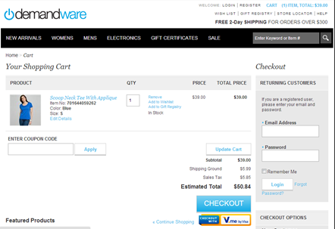

Use Case 2 - Checkout using V.me on Mini Cart
V.me API sequence on cart page.
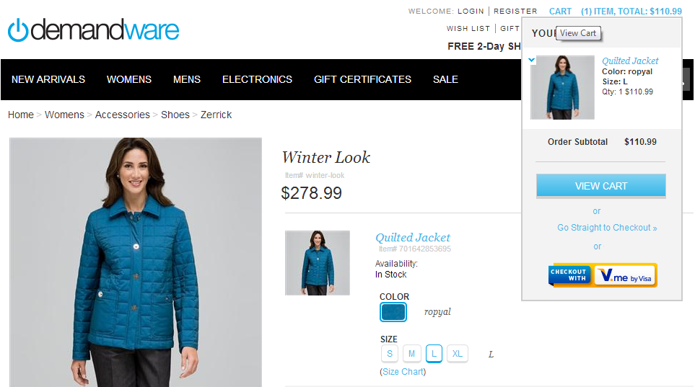

Use Case 3 - Checkout using V.me on Payment page
Payment page after “Pay with V.me” button is visible on selecting radio button “V.me” on Demandware reference site SiteGenesis.
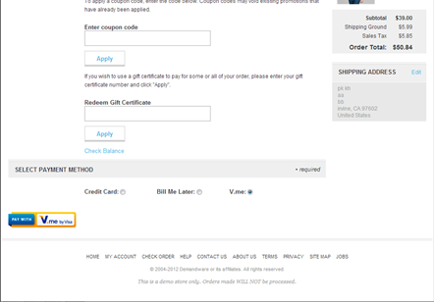
User Flows on V.me payment widget.
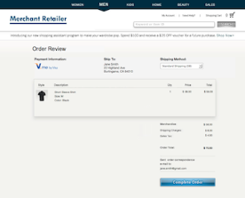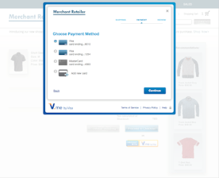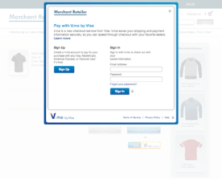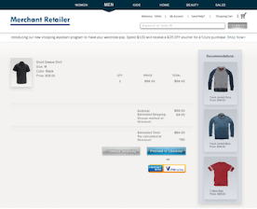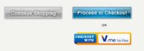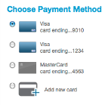

Checkout with V.me Button (Merchant Site)
V.me Sign-up/Sign-in Lightbox
Payment Method Lightbox
Complete Order Page (Merchant Site)

Retail Point-of-Sale (POS)
The use case for POS can be achieved by two scenarios:
- Hardware - swipe credit card – (A Bluetooth scanning device must be paired to the iPad device.)
On Payments page, we listen for credit card swipes only after the user has entered the amount for Credit Card and tapped enter.
Expected Result: The swiped credit card is read and payment is made to the order
- Hardware - manually enter credit card with keypad: (A Bluetooth scanning device must be paired to the iPad device.)
From Payments page, enter amount to be applied to credit card.

Expected Result: Manually enter credit card number on device and payment is accepted.

Limitations, Constraints
Not currently implemented:
- Multiple shipments. Tax rates are only calculated for a single shipment per order. To implement tax service calculation for multiple shipments, a separate web service call must be made for each distinct “ship to” location.

- Custom User Interface components to correct address validation (DAV/AVS) errors and/or omissions or to confirm “standardized” address format corrections. All pertinent data is collected, but because each merchant will have customized specifications how to deal with such information (or use other 3rd party solutions to play the same role), no default user interface is provided.
- Custom user interface for view, update and delete subscription. All functionalities are created and working in stand-alone mode in Cybersource_Subscription.xml pipeline. They have to customized and integrated as per the merchant specific needs.

- Custom user interface for Full Authorization Reversal. Full Authorization reversal is created and working in stand-alone mode in Cybersource_Services.xml pipeline. It have to customized and integrated as per the merchant specific needs.

Compatibility
This cartridge is supported under Demandware API release 2.10.0 and onward.

Implementation Guide

Before Integration
Before starting with integration process, merchant needs to identify which type of checkout flow is currently being deployed on the storefront. After the release of SiteGenesis 13.1, there are now two different types of Checkout flows possible in Demandware as explained below:
- One Step Checkout (Up to SiteGenesis 12.6)
Up to SiteGenesis 12.6, in the COPlaceOrder-Start pipeline, the order object was created after successfully calling the COPlaceOrder-HandlePayments pipeline. This ensured that an Order object was created only after receiving successful Payment Authentication message from the Payment Processor. Refer to the screenshot below:
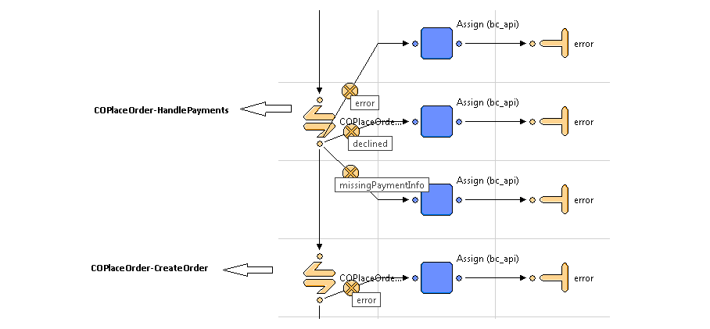

- Two Step Checkout (SiteGenesis 13.1 onwards)
SiteGenesis 13.1 release onwards, in the COPlaceOrder-Start pipeline, the Order object is created before calling the COPlaceOrder-HandlePayments pipeline. This allowed the merchants to create an Order in Business Manager with fail status, even in case of a failed Payment Authorization. Refer to the screenshot below:
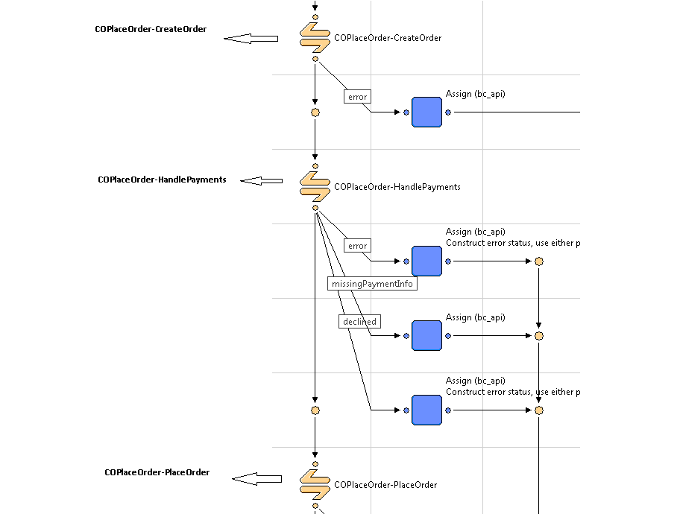

Custom Code

Credit Card Auth
Update CYBERSOURCE_CREDIT-Authorize pipeline to call Cybercource-AuthorizeCreditCard pipeline.
NOTE: Refer to the screen below for changes:
The following screen is based on Up to SiteGenesis 12.6
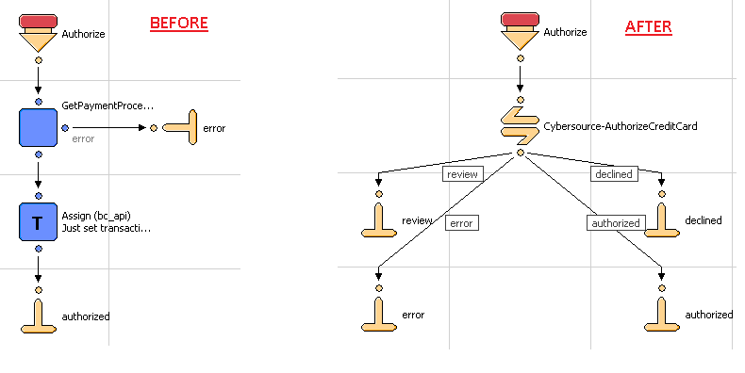

The following screen is based on SiteGenesis 13.1
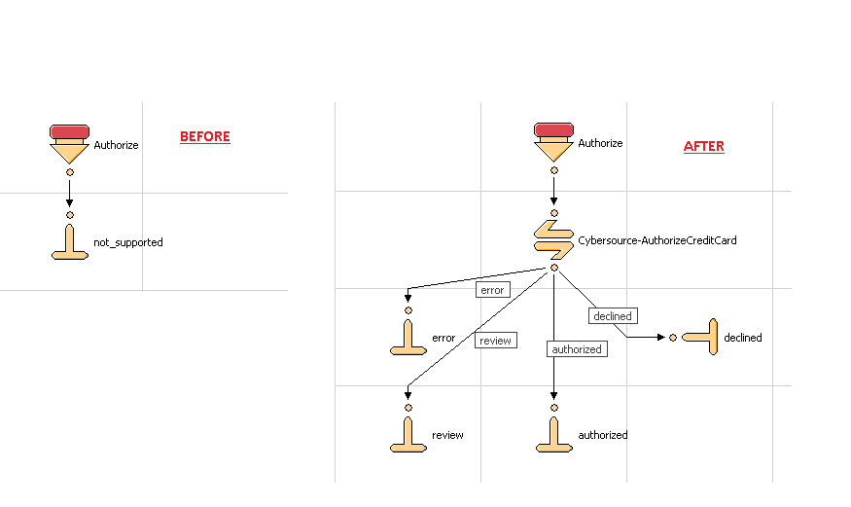

Update COPlaceOrder-CreateOrder Pipeline to include an assign node just after the createorder2 pipelet. Refer to the screenshot below for more details:
Note: This change is required only for Merchants using the Two Step Checkout Flow.
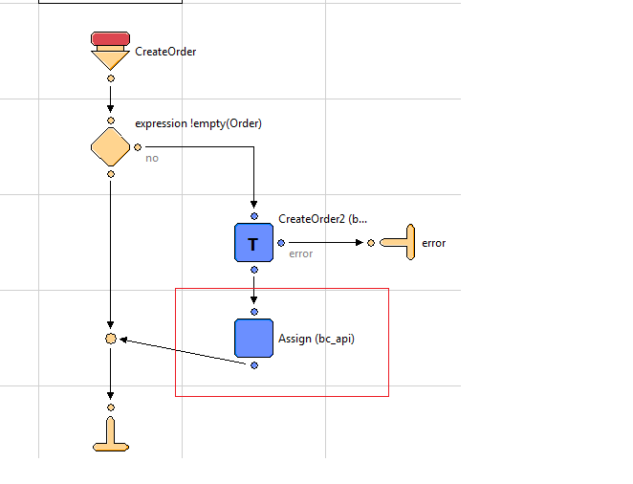
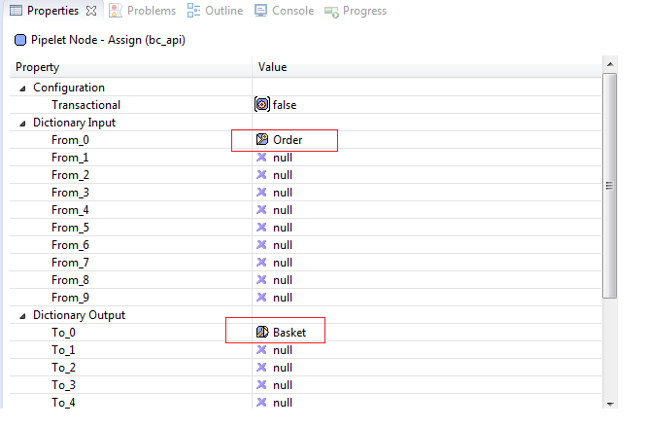

Add assign node just before FailOrder pipelet and null the Basket instance created at the time of createOrder2 pipelet.
NOTE: Refer to the screen below for changes:
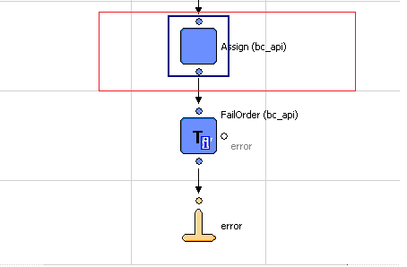
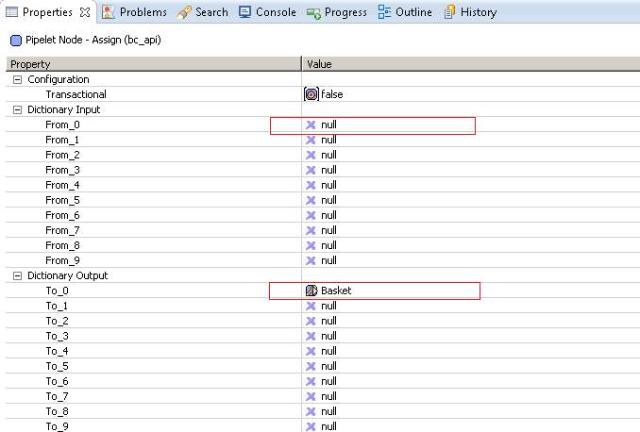

Also, update HandlePayments pipeline to handleresponse code returned by Cybersource
Authorized
Error
Declined and
Review
Note: Refer to screen below for changes:
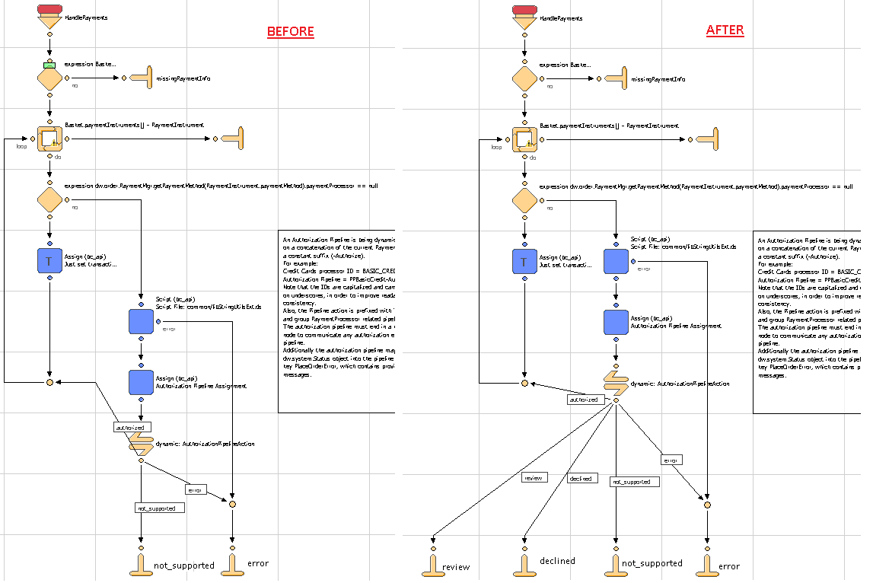

Bill Me Later
Update COPlaceOrder-HandlePayments pipeline to include Cybersource-AuthorizeBML.
Add logic to handle following responses from the Cybersource-AuthorizeBML:
Authorized
Error
Declined
Note: Refer to screenshot below for changes:
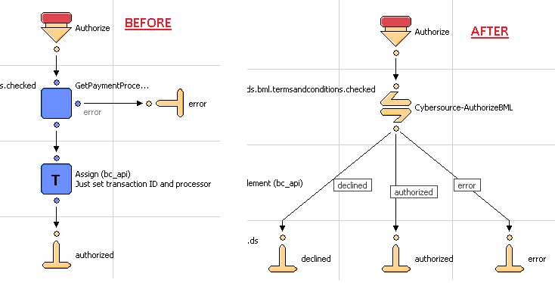

Tax Service
Update Cart-Calculate pipeline to run the Cybersource-CalculateTaxes call node after running the cart/calculateCart.ds script.
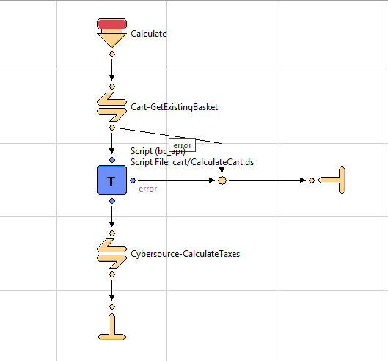
Comment out the built in tax calculation function call in cart/calculateCart.ds
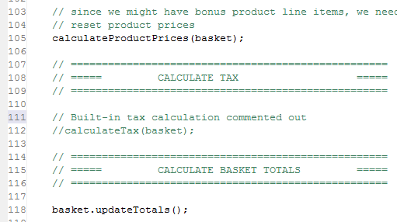
In order to avoid tax calculation call multiple times, set parameter SkipTaxCalculation to true in current session scope in the COShipping-UpdateShippingMethodList pipeline. Refer to the following screenshot:
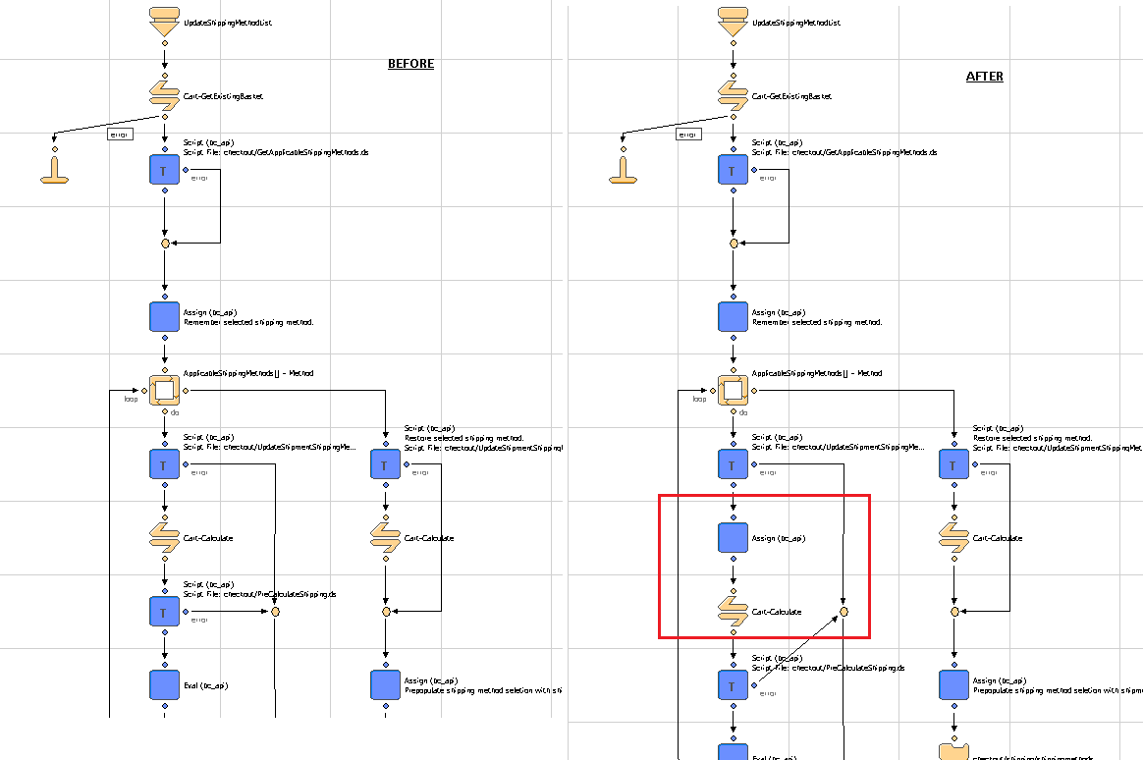
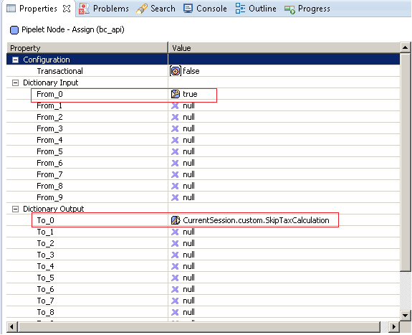
Set cartStateString parameter in current session to null after order has been placed, just before order_createdend node in the COPlaceOrder-Start pipeline. Refer to the following screenshots:

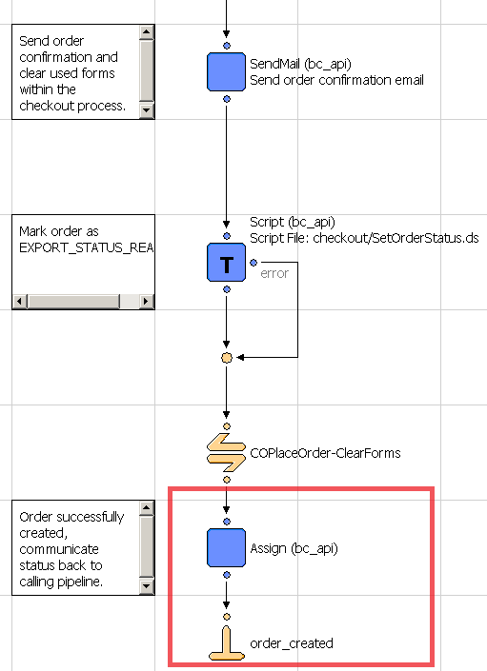
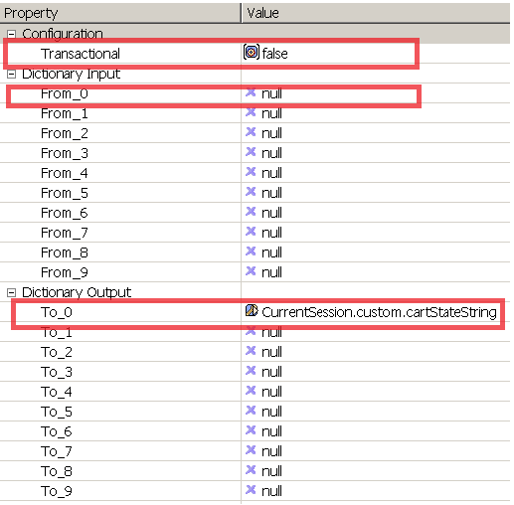

Address Verification Service
Provide Site Preference values for 2 AVS-related business rules:
CsAvsIgnoreResult – Determines whether AVS failures will force an auth failure
CsAvsDeclineFlags –Determines how “correct” an address must be to produce a failure result
Augment UI interaction nodes to deal with AVS failure or correction confirmation dialogs, wherever Payment Authorization takes place, typically within the COPlaceOrder-Start and COSummary-Submit pipelines.

Delivery Address Validation Service
Provide Site Preference values for 2 DAV-related business rules:
CsDavEnable – Determines whether DAV features are enabled for payment auth requests
CsDavOnAddressVerificationFailure –Determines whether a DAV failure will result in a payment auth failure
Augment UI interaction nodes to deal with AVS failure or correction confirmation dialogs, wherever Payment Authorization takes place, typically within the COPlaceOrder-Start and COSummary-Submit pipelines.

Full Authorization Reversal
Full Authorization reversal is created and working in stand-alone mode in Cybersource_Services.xml pipeline. It has to customized and integrated as per the merchant specific needs.

Payer Authentication Service
Provide Site Preference values for 5 Payment Authorization related business rules:
CyberSource Merchant ID (PA):– Determines which Cybersource merchant id to be used for payer authentication. It can be same as default merchant id as well.
CyberSource Merchant Password (PA): –Password corresponding to the merchant account.
CyberSource Merchant Name (PA): –Merchant Name to be used for service.
CyberSource Save Proof.xml (PA): –Determines whether to save proof.xml (received from Cybersource response) as part of order object.
CyberSource Save ParesStatus(PA): –Determines whether to pass ParesStatus received as input parameter from Pa authorization request as input parameter to ccAuthorization request.

Update COPlaceOrder-HandlePayments pipeline to make custom loop to iterate through all the payment methods set in the basket.
NOTE: This is required as a result of a limitation of Loop Node due to which it does not work properly when an Interaction continue node is encountered in a loop.
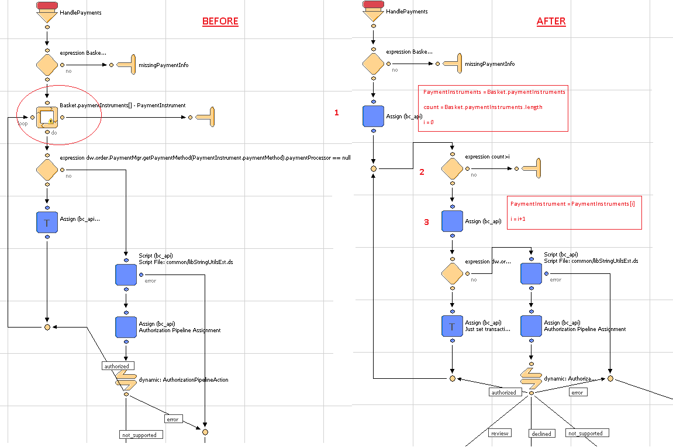

In the diagram above, the loop node in the left side image is now replaced by a custom loop code, created using two Assign nodes and one Decision node. The configuration of Assign node is same as mentioned in the right side image.

Payment Tokenization Service
Update the form creditcard.xml
Include the following form field in the form:
<!-- field for credit card subscription -->
<field formid="isSubscription" type="boolean" mandatory="false" default-value="false"/>
<field formid="maskedFourDigit"label="creditcard.number" type="string" masked="4" max-length="16"/>

Update the template creditcardjson.isml
Replace the following code block
expirationYear:pdict.SelectedCreditCard.creditCardExpirationYear
With the following code block:
expirationYear:pdict.SelectedCreditCard.creditCardExpirationYear,
isSubscription:pdict.SelectedCreditCard.custom.isSubscription,
maskedFourDigit:pdict.SelectedCreditCard.custom.maskedFourDigit

Update the form customeraddress.xml
Include the following code just before adding the action events
<!-- email field is contained in separate form group to enable binding to customer profile -->
<group formid="email">
<field formid="emailAddress" label="profile.email" type="string" mandatory="true" regexp="^[\w.%+-]+@[\w.-]+\.[\w]{2,6}$" binding="email" max-length="50" missing-error="forms.address.email.invalid" range-error="forms.address.email.invalid" parse-error="forms.address.email.invalid" value-error="forms.address.email.invalid"/>
</group>

Update the form paymentinstruments.xml.
Replace the following code block to include the customeraddress.xml form:
<include formid="newcreditcard" name="creditcard"/>
With the following code block:
<include formid="newcreditcard" name="creditcard"/>
<include formid="address" name="customeraddress"/>

Update the template paymentinstrumentdetails.isml.
Include the following code block just after the <h1> tag to display the title message
<isif condition="${pdict.SubscriptionError != null}">
<div class="error-form">
${Resource.msg('account.subscription','account',null)}
</div>
</isif>

Update the template paymentinstrumentdetails.isml.
Include the following code right after the for field for card expiration year
<!-- code comments for adding new billing fields..-->
<isinputfield formfield="${pdict.CurrentForms.paymentinstruments.creditcards.address.firstname}" type="input"/>
<isinputfield formfield="${pdict.CurrentForms.paymentinstruments.creditcards.address.lastname}" type="input"/>
<isinputfield formfield="${pdict.CurrentForms.paymentinstruments.creditcards.address.address1}" type="input"/>
<isinputfield formfield="${pdict.CurrentForms.paymentinstruments.creditcards.address.address2}" type="input"/>
<isinputfield formfield="${pdict.CurrentForms.paymentinstruments.creditcards.address.country}" type="select"/>
<isinputfield formfield="${pdict.CurrentForms.paymentinstruments.creditcards.address.states.state}" type="select"/>
<isinputfield formfield="${pdict.CurrentForms.paymentinstruments.creditcards.address.city}" type="input"/>
<isinputfield formfield="${pdict.CurrentForms.paymentinstruments.creditcards.address.zip}" type="input"/>
<isinputfield formfield="${pdict.CurrentForms.paymentinstruments.creditcards.address.phone}" type="input"/>
<isinputfield formfield="${pdict.CurrentForms.paymentinstruments.creditcards.address.email.emailAddress}" xhtmlclass="email" type="input"/>
<!-- end code changes for billing fields. -->

Update the template paymentinstrumentlist.isml.
Include the following code just before
<div class="section-header"> to display the error message for delete subscription
<isif condition="${pdict.SubscriptionError != null}">
<div class="error-form">
${Resource.msg(paymentinstrumentlist.deletesubscription','account',null)}
</div>
</isif>

Update the account.properties.
Include the following code just at end of the account.properties file to display error messages
paymentinstrumentlist.deletesubscription=An error occurred while deleting subscription.
account.subscription = Subscription is not created. Please check your card details.

Update template minicreditcard.isml.
To display masked four digits instead of credit card number.
Add a variable within isscript block:
varmaskedFourDigit : String;

Assign the value into maskedFourDigit within if(pdict.p_card != null )
maskedFourDigit = pdict.p_card.custom.maskedFourDigit;

Replace the block of code:
<isif condition="${!empty(ccOwner) && !empty(ccType) && !empty(ccNumber)}">
<isprint value="${ccOwner}"/><br />
<isprint value="${ccType}"/><br />
<isprint value="${ccNumber}"/><br />
With following code block:
<isif condition="${!empty(ccOwner) && !empty(ccType) && !empty(maskedFourDigit)}">
<isprint value="${ccOwner}"/><br />
<isprint value="${ccType}"/><br />
<isprint value="${maskedFourDigit}"/><br />

Update the template paymentmethods.isml.
Include the following code before the credit card number field
<isinputfield formfield="${pdict.CurrentForms.billing.paymentMethods.creditCard.maskedFourDigit}" type="input"/>

Update the template paymentmethods.isml.
Include the following code right after the credit card expiration year field

<isinputfield formfield="${pdict.CurrentForms.billing.paymentMethods.creditCard.isSubscription}" type="hidden" />

Update the template paymentmethods.isml.
Replace the following code within select input type (Select a Credit Card)
<isprint value="${creditCardInstr.maskedCreditCardNumber}"/>
With
<isprint value="${creditCardInstr.custom.maskedFourDigit}"/>

Update the pipeline COBilling-Start.
Add Assign node just before interaction continue node to set isSubscrition form field “false”
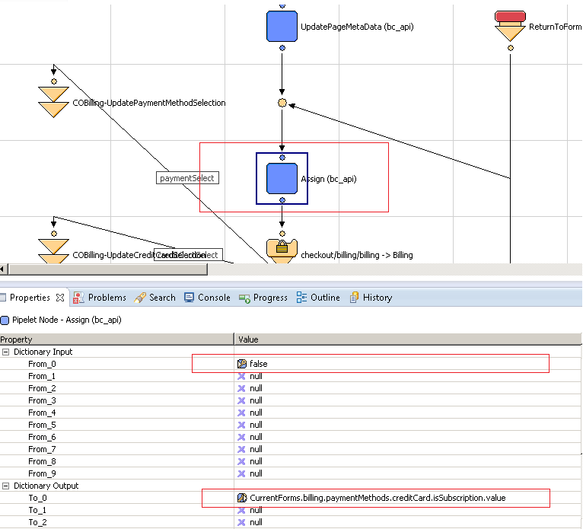

Update the pipeline COBilling-SelectCreditCard.
Update the assign node just after GetCustomerCreditCard.ds.

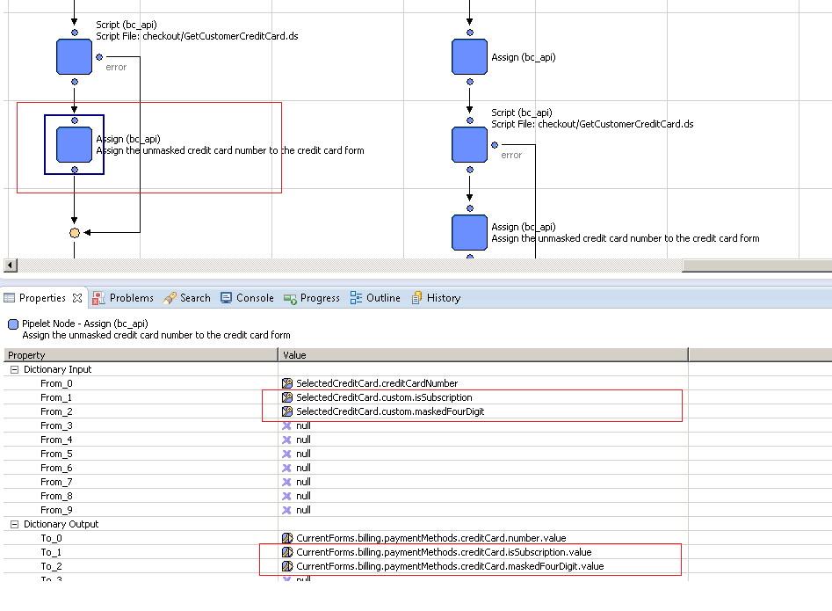

Update the pipeline COBilling-SaveCreditCard.
Add Conditional Node to check if the current payment card is a saved subscription or not. If not make a call to Cybersource pipeline to Create Subscription.
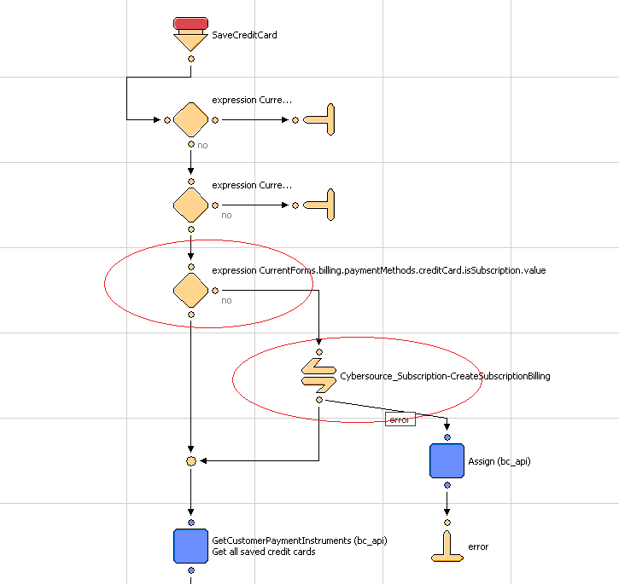

Update the pipeline COBilling-SaveCreditCard .
Add logic to save generated subscription id to customerpaymentinstrument&orderpaymentinstruments object.
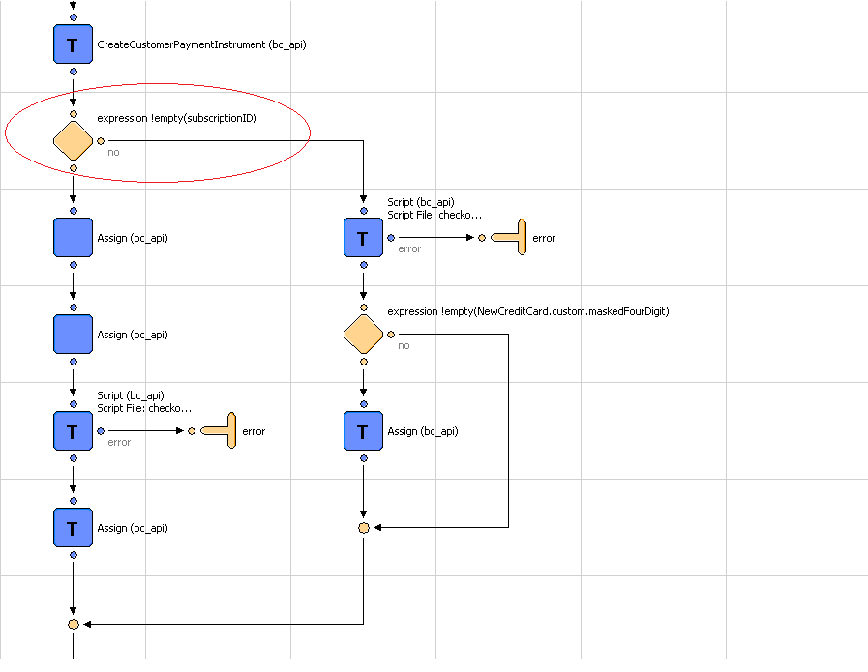

Update the pipeline COBilling-SaveCreditCard.
Add assign node after conditional block of subscriptionID to assign credit card number to masked four digit form field.

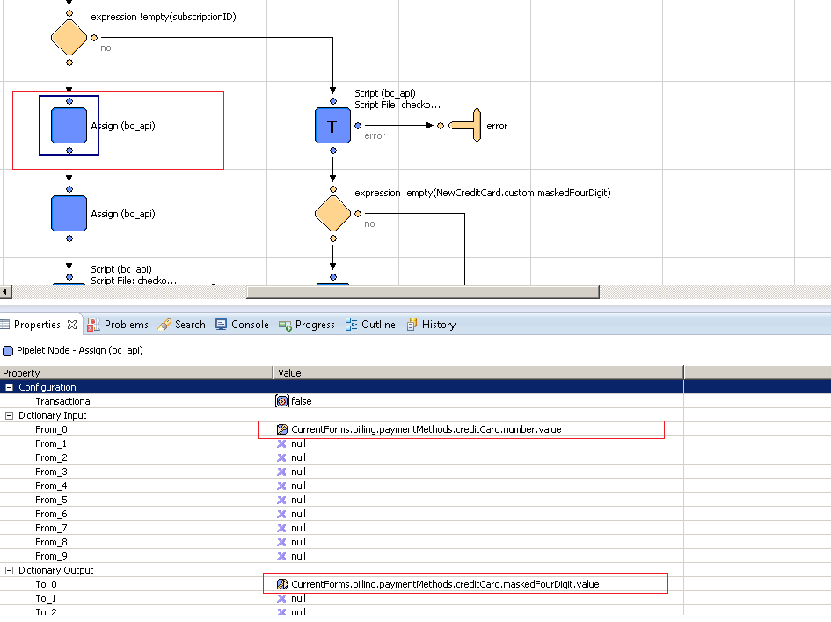

Add assign node just before SaveCustomerCreditCard.ds to update credit card number with subscriptionID.
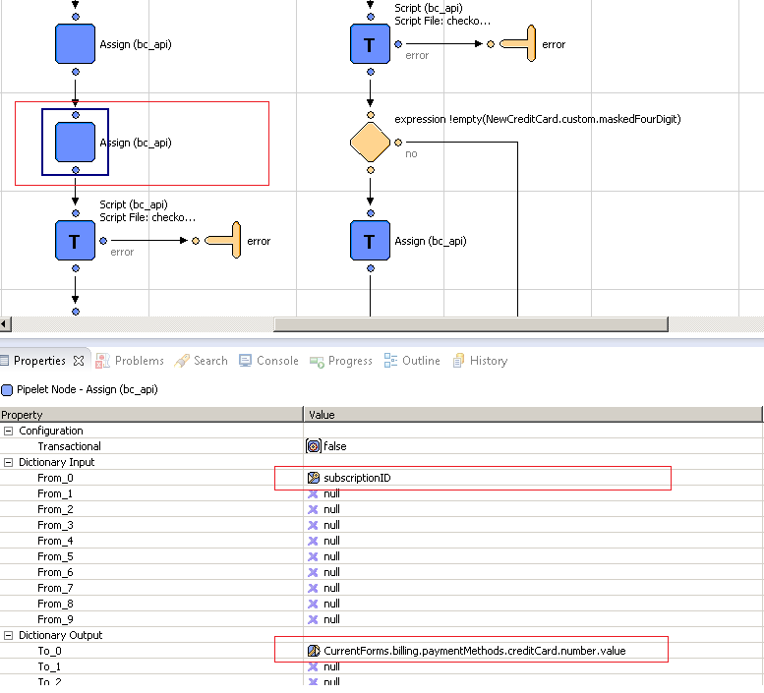

Add another assign node just after SaveCustomerCreditCard.ds to update customerpaymentinstruments&orderpaymentinsturments with subscription.

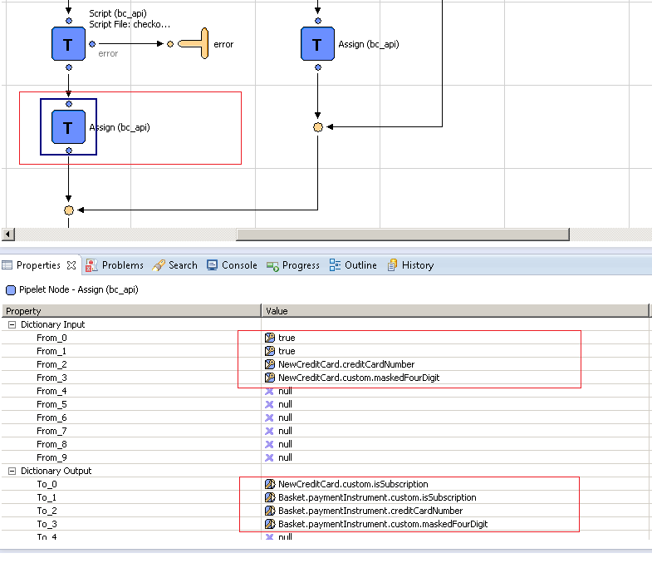

Update the script SaveCustomerCreditCard.ds to update customerpaymentinstruments with credit card form fields. Add the following code block after paymentInstr.setCreditCardType( creditCardFields.type.value ):

if(!empty(creditCardFields.isSubscription.value))
paymentInstr.custom.isSubscription = creditCardFields.isSubscription.value;
if(!empty(creditCardFields.maskedFourDigit.value))
paymentInstr.custom.maskedFourDigit = "************"+creditCardFields.maskedFourDigit.value.slice(creditCardFields.maskedFourDigit.value.length-4,creditCardFields.maskedFourDigit.value.length);

Update the pipeline COBilling-SaveCreditCard. If subscriptionID is empty.
Add the following expression node & assign node:

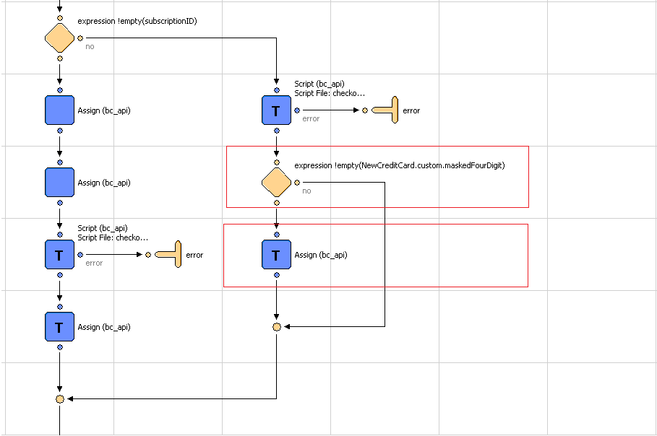

In assign node in above figure. Update the paymentinsturments custom attributessubscriptionID&isSubscription.

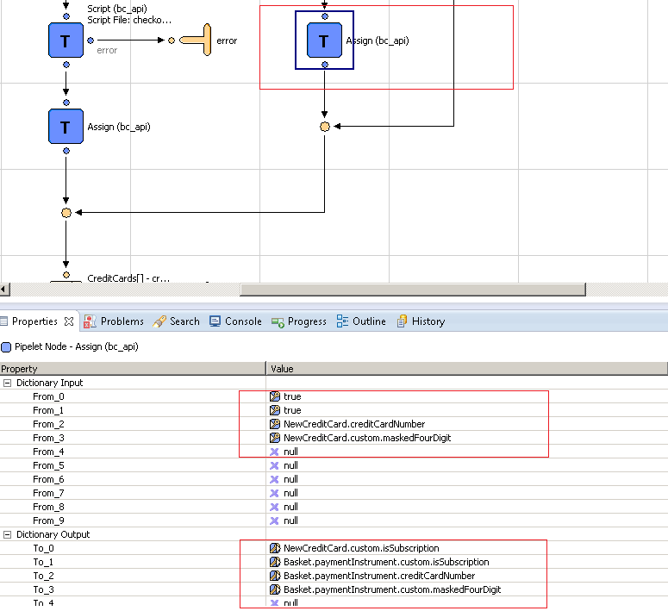

Update app.js. Update initializeCache function.
Add following code block at the end within if ($cache.checkoutForm.hasClass("checkout-billing")) condition:
$cache.ccSubscription = $cache.ccContainer.find("input[name$='creditCard_isSubscription']");
$cache.ccSubscription.val(false);
$cache.ccMaskedFourDigit = $cache.ccContainer.find("input[name$='creditCard_maskedFourDigit']"); $cache.ccMaskedFourDigit.parent().hide();
if($cache.ccMaskedFourDigit.val()=='undefined' || $cache.ccMaskedFourDigit.val()=="")
{
$cache.ccMaskedFourDigit.parent().hide();
}
else
{
$cache.ccMaskedFourDigit.parent().show();
$cache.ccNum.parent().hide();
$cache.ccSubscription.val(true);
}

Update app.js. Update setCCFields function.
Add the following code block after
$cache.ccYear.val(data.expirationYear):
$cache.ccSubscription.val(data.isSubscription);
$cache.ccMaskedFourDigit.val(data.maskedFourDigit);
$cache.ccMaskedFourDigit.parent().show();
$cache.ccNum.parent().hide();

Update the pipeline BASIC_CREDIT-Handle to skip the subscription id for card validation.

Add Script node CreatePaymentInstrument.ds to create PaymentInstrument for subscription.
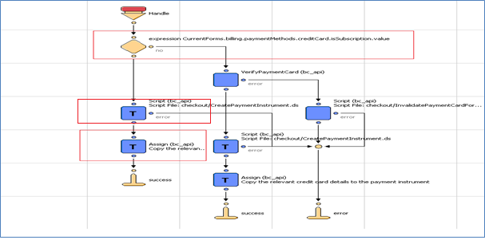

Assign the Input/output parameter as shown in figure below:
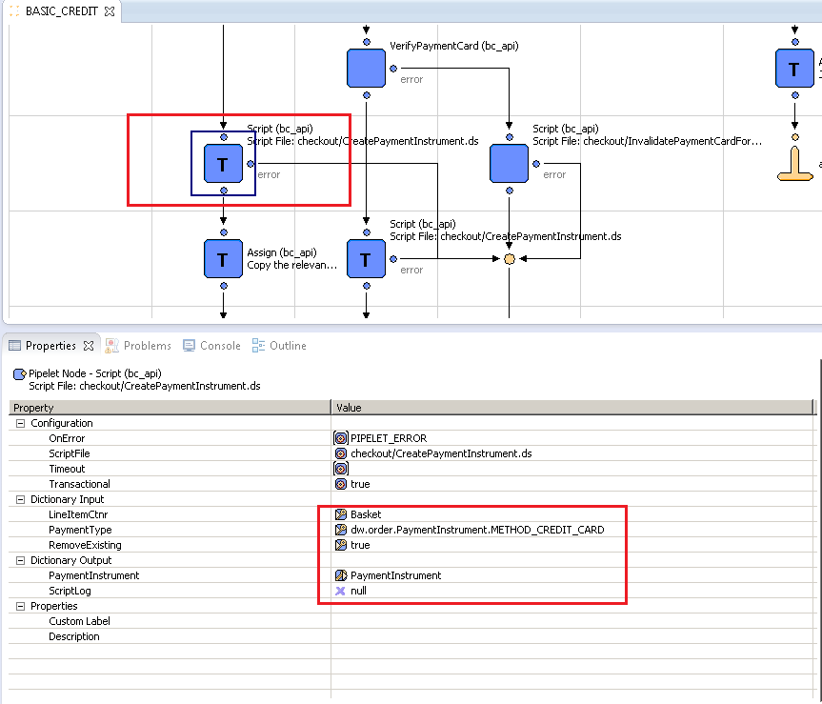

And assign current forms values to PaymentInstrument.

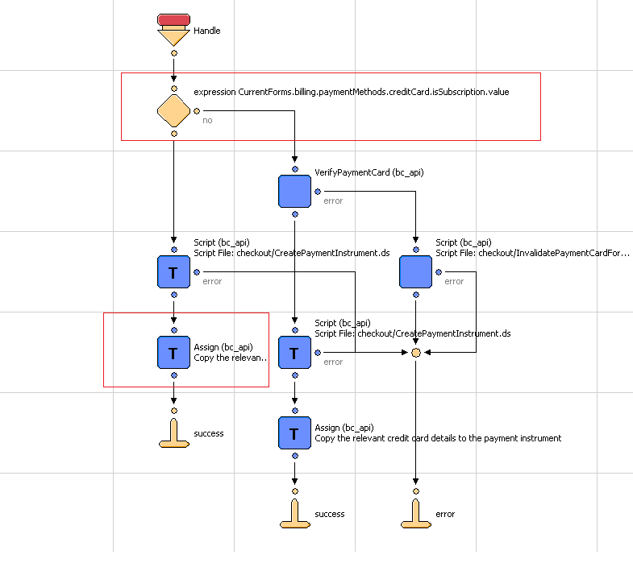

Assign the current credit card form fields values to PaymentInstruments as shown in screen below:

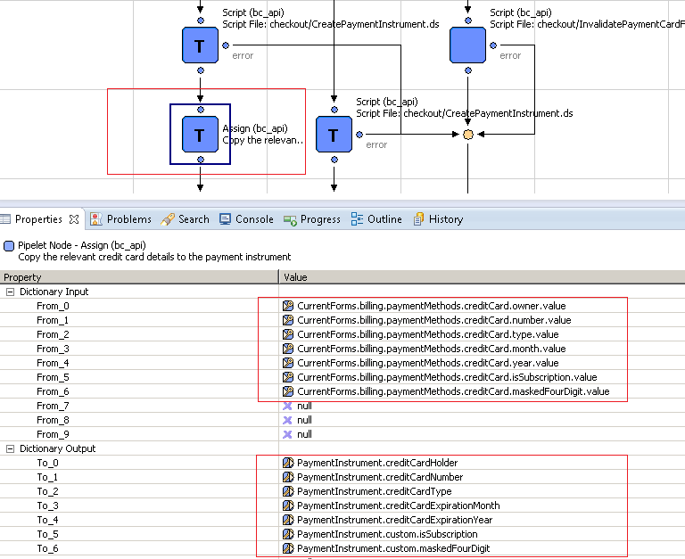

Update the pipeline PaymentInstruments-Add to make a call to Cybersource pipeline to Create Subscription.
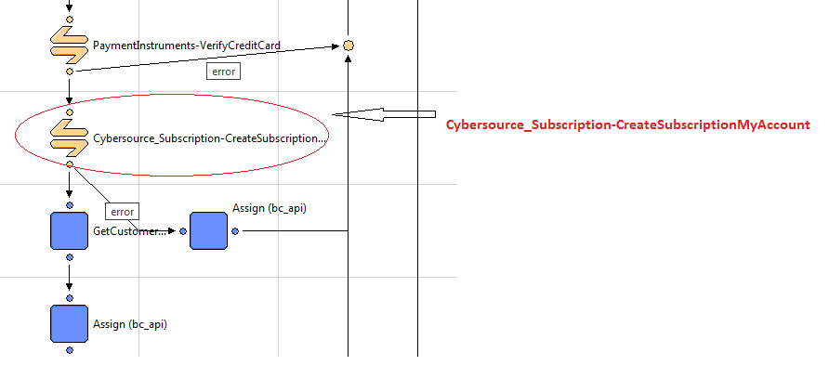

Add assign node just after call node at error connector. And assign the value as shown in screen below:

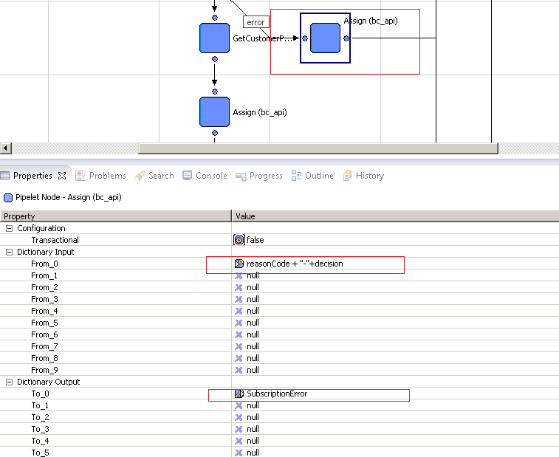

Add assign node just after GetCustomerPaymentInsturments.
Assign the credit card number to masked four digit (newly created field in creditcard.xml)

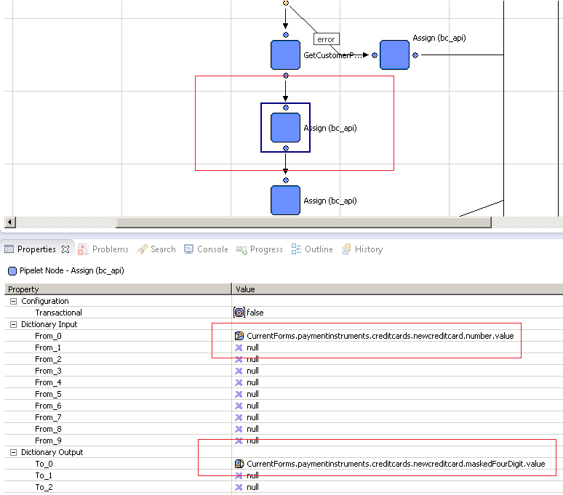

Add assign node just after UpdateObjectWithForm within same pipeline flow.
Update the customer payment instrument with isSubscription&maskedFourDigit (Make sure pipelet should be transactional).

Assign the following value:
************"+CurrentForms.paymentinstruments.creditcards.newcreditcard.maskedFourDigit.value.slice(CurrentForms.paymentinstruments.creditcards.newcreditcard.maskedFourDigit.value.length-4,CurrentForms.paymentinstruments.creditcards.newcreditcard.maskedFourDigit.value.length)
To
PaymentInstrument.custom.maskedFourDigit
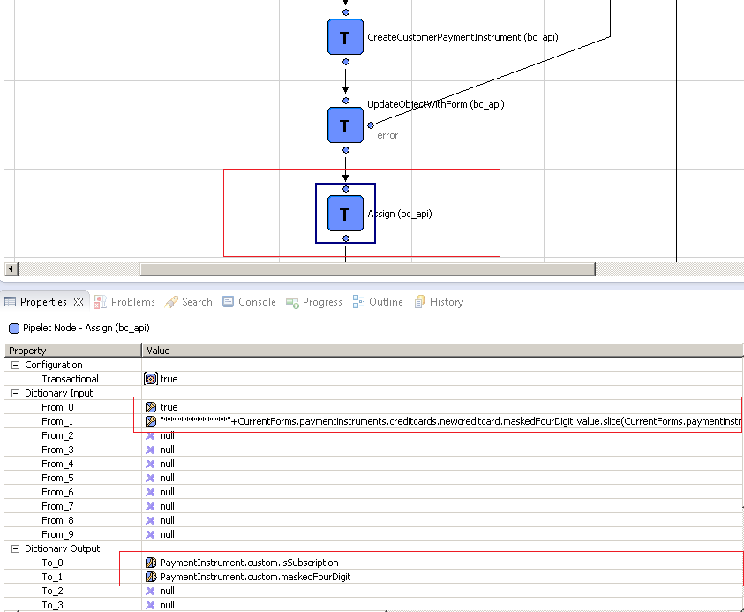

Update the pipeline PaymentInstruments-Delete to make a call to Cybersource pipeline to Delete Subscription. Add call node after expression.

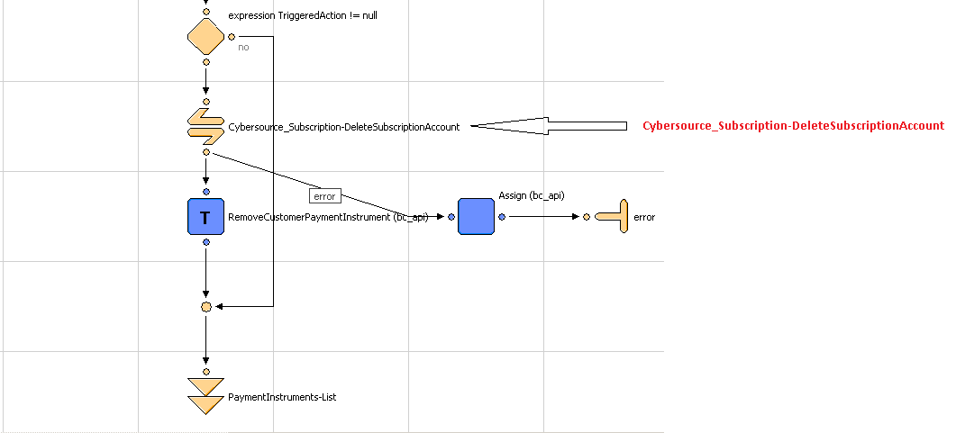

Add assign node just after call node at error connector. And assign the value as shown in screen below:

All functionalities related to Cybersource Payment Tokenization are created and working in stand-alone mode in Cybersource_Subscription.xml pipeline. They have to customized and integrated as per the merchant specific needs

V.me by Visa
In order to integrate the V.me cartridge functionality merchant has to follow the instructions given in this section.
The cartridge code also includes sample files for reference. The changes made in sample files are denoted by appropriate “BEGIN V.ME CHANGES” & “END V.ME CHANGES” tags.
Note: It is suggested that merchant does all the changes defined in this section, to achieve the desired V.me functionality.

How it Works
In order to enable V.me buy button on website, following files have to be used from int_visa_VME cartridge.
- visa_buy.isml
This file is used to make a reusable demandware module for V.me buy button. It has to be included in modules.isml, in order to be used as demandware reusable module. Once included, V.me buy button can be generated as follows:
<isvisaBuycollect_shipping="true"callback="vmeWidgetUIEventHandler"/>
  - collect_shipping parameter is used to map with V.me Collect Shipping variable.
    - True: Shipping details will be captured by V.me on payment widget
    - False: Shipping details will have to be provided by customer on merchant site.
  - Callback parameter is used to provide name of Javascript function used for receiving customer details from V.me widget.
- visa_init.isml
This file is used to integrate v:init tag into Demandware template.
- visa_root.isml
This file is used to create div required for V.me buy button. Also, it is used to include V.me proprietary javascript according to the environment (sandbox or production).
- visa_callback.isml
This file is used to include javascript callback functions required by V.me buy button.
- visa_form.isml
This file is used to include hidden html form Demandware template. Form is required to securely save V.me call-Id into Demandware order object.
Step1: Cartridge Import
Merchant needs to import both the cartridges int_visa_VME&int_cybersourcein Eclipse(with Demandware plugin) developer environment.
Step2: Enable V.me Payment Flow on Cart Page
In order to enable V.me payment flow from Cart page, merchant is required to update following files:
- Cart.xml
  - Sample File
Cart_sample.xml
  - Changes Required
- Add Call Node (COShippingVisa-PrepareVme) in Cart-Show just before Interaction Continuation Node. Refer to the screenshot below:
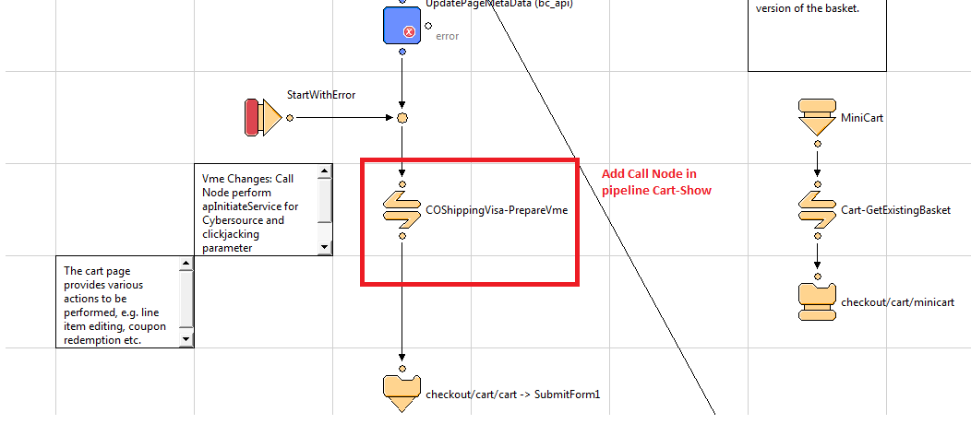

- Add Call Node (COShippingVisa-PrepareVme) in Cart-MiniCart just before Interaction Continuation Node. Refer to the screenshot below:

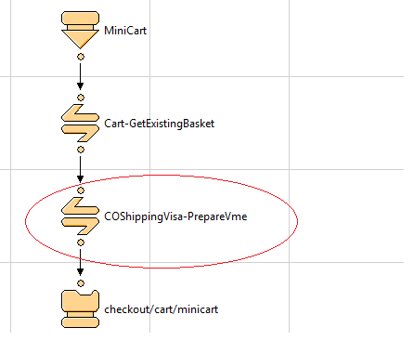

- minicart.isml
  - Sample File
minicart_sample.isml
  - Changes Required
- Add following code block just after the <isinclude template="util/modules"/> tag
//BEGIN…………………………………………………………………
<isinclude template="visa_init.isml" />
…………………………………………………………………….//END
- Add following code block immediately after anchor tag showing “Continue to Checkout” link
//BEGIN…………………………………………………………………
<isscript>
var enabled : Boolean =
dw.order.PaymentMgr.getPaymentMethod("VISA_VME").isActive();
</isscript>
<isif condition="${enabled &&dw.system.Site.getCurrent().getCustomPreferenceValue('VmeEnableVmeOnMiniCart')}">
<div class="cart-action-continue-shopping" style="margin:35px">
<isvisaBuycollect_shipping="true" callback="vmeWidgetUIEventHandler"/>
</div>
</isif>
…………………………………………………………………….//END

- COBilling.xml
  - Sample File
COBilling_sample.xml
  - Changes Required
- Add Call Node (COShippingVisa-PrepareVme) in COBilling-Start just before Interaction Continuation Node. Refer to the screenshot below:
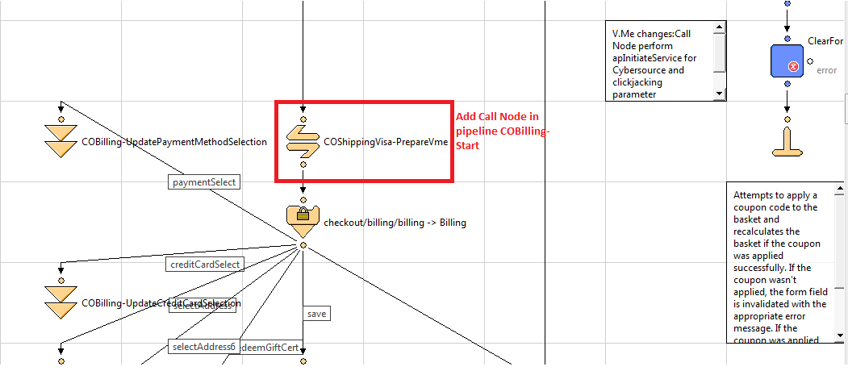
- Update Assign Node in COBilling-RedeemGiftCertificate. Refer to the screenshot below:
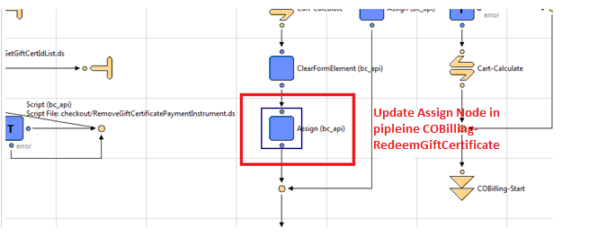
- Set the properties for this Assign Node in the Properties View as shown below:
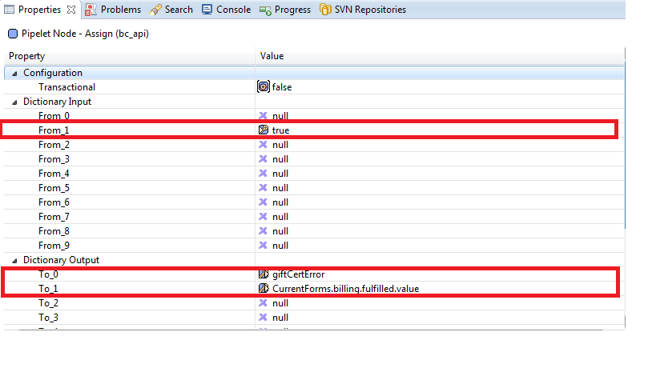

- Update the second Assign Node in COBilling-RedeemGiftCertificate. Refer to the screenshot below
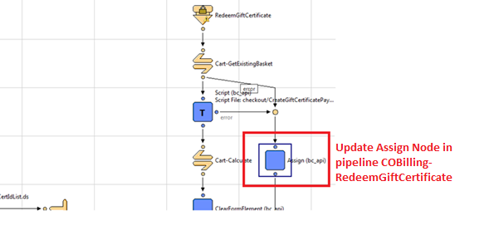
- Set the properties for this Assign Node in Properties View as shown below
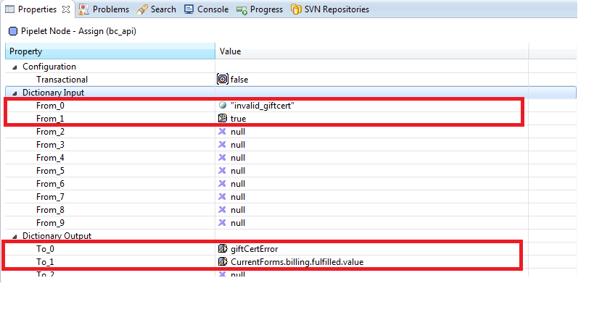

- Add Pipelet (RemoveBasketPaymentInstrument) in COBilling-ResetPaymentForms
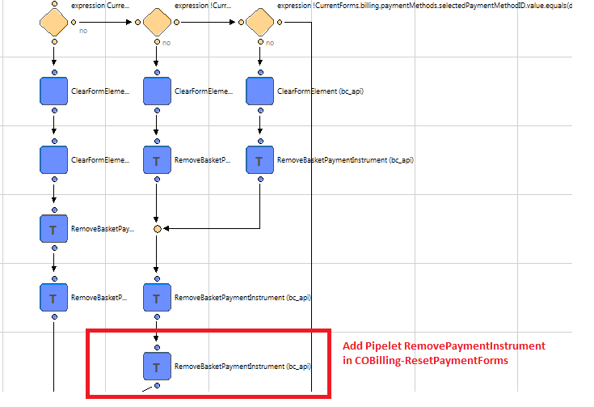
- Set the properties for this Pipelet in Properties View.
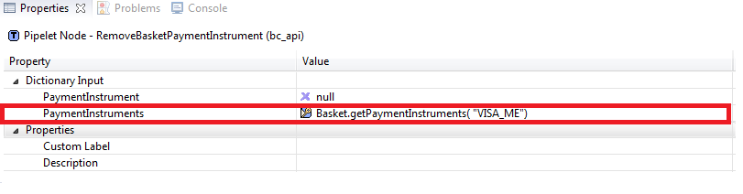
- COPlaceOrder.xml
  - Sample File
COPlaceOrder_sample.xml
  - Changes Required
- Handle responses from COPlaceOrder-HandlePayments pipeline.
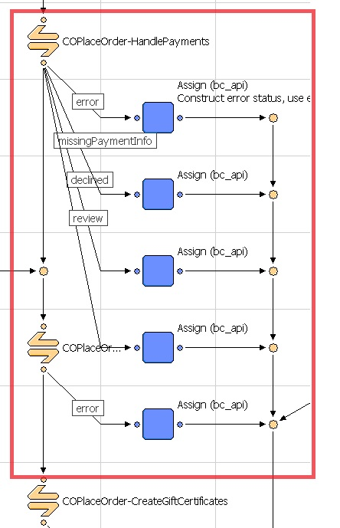
- modules.isml
  - Sample File
modules_sample.isml
  - Changes Required
- Add following code block at the end of the file
//BEGIN…………………………………………………………………
<iscomment>
Render the checkout with visa buy
</iscomment>
<isinclude template="visa_modules.isml"/>
…………………………………………………………………….//END

- htmlhead.isml
  - Sample File
htmlhead_sample.isml
  - Changes Required
- Add following code block at the end of the file
//BEGIN…………………………………………………………………
<iscomment>Style as part of clickjacking mechanism</iscomment>
<isif condition="${!empty(pdict.clickjackingflag)}">
<style> body { display : none;} </style>
</isif>
<isinclude template="visa_callback.isml"/>
…………………………………………………………………….//END
- footer.isml
  - Sample File
footer_sample.isml
  - Changes Required
- Add following code block at the end of the file
//BEGIN…………………………………………………………………
<isinclude template="visa_form.isml"/>
<isinclude template="visa_root.isml"/>
…………………………………………………………………….//END

- cart.isml
  - Sample File
cart_sample.isml
  - Changes Required
- Add following code block in the <div class = “cart-actions”>
//BEGIN…………………………………………………………………
<div class="cart-action-continue-shopping" style="clear:both">
<isscript>
var enabled : Boolean = dw.order.PaymentMgr.getPaymentMethod("VISA_VME").isActive();
</isscript>
<isif condition="${enabled}">
<isvisaBuycollect_shipping="true" callback="vmeWidgetUIEventHandler"/>
</isif>
</div>
…………………………………………………………………….//END
Note: It is suggested that merchant places the isvisabuy tag considering the DOM structure of their storefront cart page. Placement of isvisabuy tag will define the position of V.me buy button on the page.

- minibillinginfo.isml
  - Sample File
minibillinginfo_sample.isml
  - Changes Required
- Add following code block after <isset name="paymentInstruments">
//BEGIN…………………………………………………………………
<isset name="currentSite" value="${dw.system.Site.getCurrent()}" scope="page"/>
<isif condition = "${pdict.CurrentForms.billing.paymentMethods.selectedPaymentMethodID.value == 'VISA_VME'}">
<div class = "mini-billing-address order-component-block">
<h3 class = "section-header">
<a href = "${URLUtils.https('COBilling-Start')}" class = "section-header-note"> ${Resource.msg('global.edit','locale',null)}
</a>
${Resource.msg('minibillinginfo.billingaddress','checkout',null)}
</h3>
<div class="details">
<img alt="Payment_mark_small" src="${currentSite.getCustomPreferenceValue('VmeAcceptLogo')}">
</div>
</div>
<iselse>
…………………………………………………………………….//END

- Add following code block at the end of condition <isif condition="${!empty(billingAddress)}">
//BEGIN…………………………………………………………………
</iselse>
</isif>
…………………………………………………………………….//END

- Replace the following code block
<div class="mini-payment-instrument order-component-block <isif condition="${loopstate.first}"> first <iselseif condition="${loopstate.last}"> last</isif>">

With the following code block
//BEGIN…………………………………………………………………
<div class="mini-payment-instrument order-component-block">
…………………………………………………………………….//END

- Replace the following code block
<isif condition = "${loopstate.first}"><span>${Resource.msg('minibillinginfo.paymentmethod','checkout',null)}</span></isif>

With the following code block
//BEGIN…………………………………………………………………
<span>${Resource.msg('minibillinginfo.paymentmethod','checkout',null)}</span>
…………………………………………………………………….//END

- Add following code block before <div class="details"> of <isif condition="${!empty(paymentInstruments)}">
//BEGIN…………………………………………………………………
<isif condition="${paymentInstr.paymentMethod!='VISA_VME'}">
…………………………………………………………………….//END

- Add following code block after <div class="details"> of <isif condition="${!empty(paymentInstruments)}">
//BEGIN…………………………………………………………………
<iselse>
<div class="details">
<img alt="Payment_mark_small" src="${currentSite.getCustomPreferenceValue('VmeAcceptLogo')}">
</div>
</isif>
…………………………………………………………………….//END

- orderdetails.isml
  - Sample File
orderdetails_sample.isml
  - Changes Required
- Replace the following code
<isminiaddressp_address="${Order.billingAddress}"/>

With the following code block
//BEGIN---------------------------------------------------------------------------------
<isset name="addressPrinted" value="false" scope="page"/>
<isloop items="${Order.getPaymentInstruments()}" var="paymentInstr" status="piloopstate">
<isif condition="${dw.order.PaymentMgr.getPaymentMethod(paymentInstr.paymentMethod).ID =='VISA_VME' &&paymentInstr.paymentTransaction.amount> 0}">
<img alt="Payment_mark_small" src="${dw.system.Site.current.getCustomPreferenceValue('VmeAcceptLogo')}">
<iselse/>
<isif condition="${addressPrinted != 'true'}">
<isset name="addressPrinted" value="true" scope="page"/>
<isminiaddressp_address="${Order.billingAddress}"/>
</isif>
</isif>
</isloop>
---------------------------------------------------------------------------------------//END

- Replace the following code
<div class="payment-type"><isprint value="${dw.order.PaymentMgr.getPaymentMethod(paymentInstr.paymentMethod).name}" /></div>
<isminicreditcardp_card="${paymentInstr}" p_show_expiration="${false}"/>
<div class="payment-amount">
<span class="label">${Resource.msg('global.amount','locale',null)}:
</span>
<span class="value"><isprint value="${paymentInstr.paymentTransaction.amount}"/>
</span>
</div><!-- END: payment-amount -->

With the following code block
//BEGIN---------------------------------------------------------------------------------
<isif condition="${dw.order.PaymentMgr.getPaymentMethod(paymentInstr.paymentMethod).ID =='VISA_VME' &&paymentInstr.paymentTransaction.amount> 0}">
<div class="payment-type"><img alt="Payment_mark_small" src="${dw.system.Site.current.getCustomPreferenceValue('VmeAcceptLogo')}"></div>
<iselse/>
<div class="payment-type"><isprint value="${dw.order.PaymentMgr.getPaymentMethod(paymentInstr.paymentMethod).name}" /></div>
<isminicreditcardp_card="${paymentInstr}" p_show_expiration="${false}"/>
<div class="payment-amount"><span class="label">${Resource.msg('global.amount','locale',null)}:</span>
<span class="value"><isprint value="${paymentInstr.paymentTransaction.amount}"/></span>
</div><!-- END: payment-amount -->
</isif>

-------------------------------------------------------------------------------------//END

- orderdetailsemail.isml
  - Sample File
orderdetailsemail_sample.isml
  - Changes Required
- Replace the following code
<isminiaddressp_address="${Order.billingAddress}"/>

With the following code block
//BEGIN---------------------------------------------------------------------------------

<isset name="addressPrinted" value="false" scope="page"/>
<isloop items="${Order.getPaymentInstruments()}" var="paymentInstr" status="piloopstate">
<isif condition="${dw.order.PaymentMgr.getPaymentMethod(paymentInstr.paymentMethod).ID =='VISA_VME' &&paymentInstr.paymentTransaction.amount> 0}">
<div><img alt="Payment_mark_small" src="${dw.system.Site.current.getCustomPreferenceValue('VmeAcceptLogo')}"></div>
<iselse/>
<isif condition="${addressPrinted != 'true'}">
<isset name="addressPrinted" value="true" scope="page"/>
<isminiaddressp_address="${Order.billingAddress}"/>
</isif>
</isif>
</isloop>
--------------------------------------------------------------------------------------------//END

- Replace the following code
<div><isprint value="${dw.order.PaymentMgr.getPaymentMethod(paymentInstr.paymentMethod).name}" /></div>
<isif condition="${dw.order.PaymentInstrument.METHOD_GIFT_CERTIFICATE.equals(paymentInstr.paymentMethod)}"><isprint value="${paymentInstr.maskedGiftCertificateCode}"/><br />
</isif>
<isminicreditcardp_card="${paymentInstr}" p_show_expiration="${false}"/>
<div><span class="label">${Resource.msg('global.amount','locale',null)}:</span>
<span class="value"><isprint value="${paymentInstr.paymentTransaction.amount}"/></span>
</div><!-- END: payment-amount -->
With the following code block
//BEGIN---------------------------------------------------------------------------------

<isif condition="${dw.order.PaymentMgr.getPaymentMethod(paymentInstr.paymentMethod).ID =='VISA_VME' &&paymentInstr.paymentTransaction.amount> 0}">
<div><img alt="Payment_mark_small" src="${dw.system.Site.current.getCustomPreferenceValue('VmeAcceptLogo')}"></div>
<iselse/>
<div><isprint value="${dw.order.PaymentMgr.getPaymentMethod(paymentInstr.paymentMethod).name}" /></div>
<isif condition="${dw.order.PaymentInstrument.METHOD_GIFT_CERTIFICATE.equals(paymentInstr.paymentMethod)}">
<isprint value="${paymentInstr.maskedGiftCertificateCode}"/><br />
</isif>
<isminicreditcardp_card="${paymentInstr}" p_show_expiration="${false}"/>
<div><span class="label">${Resource.msg('global.amount','locale',null)}:</span>
<span class="value"><isprint value="${paymentInstr.paymentTransaction.amount}"/></span>
</div><!-- END: payment-amount -->
</isif>

--------------------------------------------------------------------------------------------//END

Step3: Enable V.me Payment Flow on Payment Page
In order to enable V.me payment flow from Payment page, merchant is required to update following files:

- billing.isml
  - Sample File
billing_sample.isml
  - Changes Required
- Replace the following code
<fieldset>

With the following code block
//BEGIN---------------------------------------------------------------------------------
<iscomment>block of code to display V.me logo with description</iscomment>
<isif condition="${pdict.CurrentForms.billing.paymentMethods.selectedPaymentMethodID.value==
'VISA_VME'}">
<div id="vme-legend">
<legend>
Billing Address Provided By V.me
</legend>
<div>
<div class="details">
<img alt="Payment_mark_small" src="${dw.system.Site.current.getCustomPreferenceValue('VmeAcceptLogo')}">
</div>
<div></div>
</div>
</div>
</isif>
<fieldset id="billing-form">
----------------------------------------------------------------------------------//END

- Replace the following code
<div class="form-row form-row-button">
With the following code block
//BEGIN------------------------------------------------------------------------------
<div class="form-row form-row-button" id="continue-button">
-----------------------------------------------------------------------------------//END

- paymentmethods.isml
  - Sample File
paymentmethods_sample.isml
  - Changes Required
- Add the following code after <div id="PaymentMethod_BML"> ends

//BEGIN---------------------------------------------------------------------------------
<div id="PaymentMethod_VISA_VME" class="payment-method <isif condition="${!empty(pdict.selectedPaymentID) &&
pdict.selectedPaymentID=='VISA_VME'}">payment-method-expanded</isif>">
<isvisaBuycollect_shipping="false" callback="vmeWidgetUIEventHandler" />
</div>
----------------------------------------------------------------------------------//END
- app.js
  - Sample File
app _sample.js
  - Changes Required
- Add the following code in function changePaymentMethod(paymentMethodID) after line pmc.addClass("payment-method-expanded")

//BEGIN---------------------------------------------------------------------------------
$cache.checkoutForm.find("#billing-form").show();
$cache.checkoutForm.find("#continue-button").show();
$cache.checkoutForm.find("#vme-continue-button").hide();
$cache.checkoutForm.find("#vme-legend").hide();
----------------------------------------------------------------------------------//END
- Add the following code in function changePaymentMethod(paymentMethodID) after condition if (paymentMethodID=="BML")

//BEGIN---------------------------------------------------------------------------------
if(paymentMethodID==="VISA_VME")
{
$cache.checkoutForm.find("#billing-form").hide();
$cache.checkoutForm.find("#continue-button").hide();
$cache.checkoutForm.find("#vme-continue-button").show();
$cache.checkoutForm.find("#vme-legend").show();
}
----------------------------------------------------------------------------------//END

Clickjacking Prevention

What is Clickjacking

Clickjacking (also known as user-interface redressing and IFRAME overlay) is an exploit in which malicious coding is hidden beneath apparently legitimate buttons or other clickable content on a website. It can be used for malicious actions, such as stealing confidential information, that are perpetrated against a user who is browsing a Web site. The user is “hijacked” by clicking a link on a contaminated Web page that executes the malware. The buttons may appear legitimate, but users are actually clicking buttons on a transparent layer they cannot see. The buttons can cause anything to happen, including making a purchase.
Prevention
Merchants must implement 2 mechanisms to ensure full protection from Clickjacking:
- Client side stylesheet/Javascript
<html>
<head>
...
<style id=”antiClickjack”>body{display:none;}</style>
<script type=”text/javascript”>
if (self === top) {
varantiClickjack = document.getElementById(“antiClickjack”);
antiClickjack.parentNode.removeChild(antiClickjack);
} else {
top.location = self.location;
}
</script>
...
</head>
<body>
...
</body>
</html>
Note:The cartridge code already constitutes Client side code for Clickjacking prevention. Merchant does not need to perform any extra tasks in order to enable Client side Clickjacking prevention.
- Server Side
Merchant must implement X-FRAME-OPTIONS with either “X-FRAME-OPTIONS DENY” OR “X-FRAME-OPTIONS SAMEORIGIN” on all pages wheretheV.me Payment Widget is hosted.
Note: Due to Demandware platform restriction for 12.6 or below, Server side code for Clickjacking prevention could not be included in the cartridge. Merchants are advised to raise a support ticket with Demandware Product Support team in order to get Server Side code enabled on Production environment.
Merchant must disable server side Clickjacking from Business Manager Site preference.

Note:For Demandware 13.3 and above, Server side code for Clickjacking is enabled. Merchantmust enable server side Clickjacking from Business Manager Site preference.

https://documentation.demandware.com/display/ReleaseNotes/DW+Platform+13.3

Testing Clickjacking Prevention Code
Follow these steps to test your Clickjacking prevention code implementation:

- Install a host http server and write a simple html page to iFrame the V.me customer.
  - For host HTTP server, you can download and install Apache Tomcat (http://tomcat.apache.org/index.html)
  - Create an HTML page, such as the following:
<html>
<body>
<iframesrc="https://www.yoursite.com/" width=100% height=100%>
<p>Your browser does not support iframes.</p>
</iframe>
</body>
</html>
- The iFramesrc in the test HTML page should point to your customer’s page which hosts the V.me lightbox.
- If the both options (frame busting script and X-Frame-options) are implemented correctly in your customer’s V.me page, you should observe the following:
  - IE8+
You see “this content cannot be displayed in a frame” error message:
- On other X-Frame-options supported browsers, you should see a blank page.
- For all versions prior to the X-Frame-options supported versions, including IE7, your frame busting script should kick in to bust your customer site out of your hosted HTML page.
Note: You cannot put your site in an iFrame.

Order Export XML – New Fields
After successful integration of the cartridge, Merchants can use the V.me button on Cart page and Payment page to process the Checkout flow.
On successful Order Checkout, using V.me as payment instrument, merchants can verify the V.me call Id and V.me Authorization ID by referring Order object created in Demandware Business Manager. Refer to the screen below for Order Object impact:
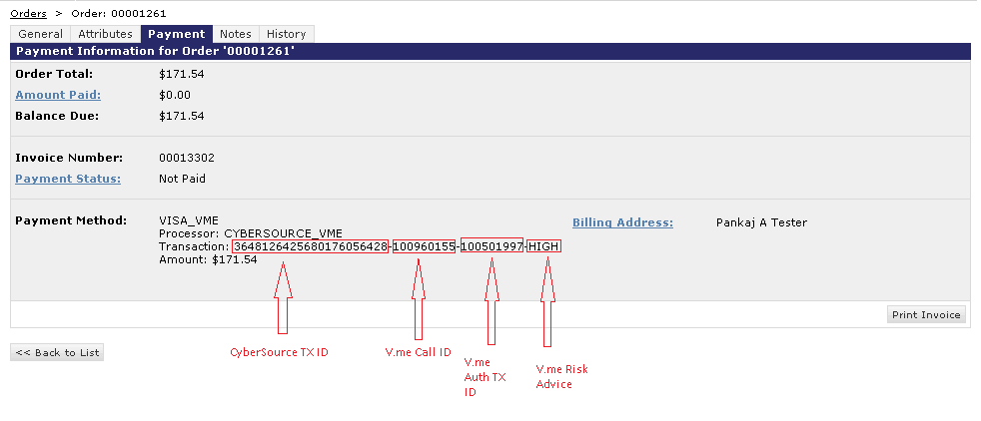
Note two important changes in Payment Tab of the Order Object:
- Processor: CYBSERCOURCE_VME
- Transaction: This field will contain fields separated by delimiter ‘-‘. Format for this field is:
{Cybersource Tx ID} - {Call Id} - {Authorization Id}-{Risk Advice}
- Call Id -Call Id generated by V.me payment Widget.
- Authorization Id -Transaction ID returned by Visa server for Payment Authorization request for specific order.
- Risk Advice -Risk Advice returned by Payment Authorization request for specific order.

Refer to the sample Order XML for new fields in Order Export
<?xml version="1.0" encoding="UTF-8" ?>
<orders xmlns="http://www.demandware.com/xml/impex/order/2006-10-31">
<order order-no="00001251">
<order-date>2013-03-26T09:38:25.627Z</order-date>
<created-by>storefront</created-by>
<original-order-no>00001251</original-order-no>
<currency>USD</currency>
<customer-locale>default</customer-locale>
<invoice-no>00013101</invoice-no>
<customer>
<customer-no>00007501</customer-no>
<customer-name>Pankaj A Tester</customer-name>
<customer-email>pankajtester9@gmail.com</customer-email>
<billing-address>
<first-name>Pankaj A</first-name>
<last-name>Tester</last-name>
<phone>2039121212</phone>
</billing-address>
</customer>
<status>
<order-status>OPEN</order-status>
<shipping-status>NOT_SHIPPED</shipping-status>
<confirmation-status>CONFIRMED</confirmation-status>
<payment-status>NOT_PAID</payment-status>
</status>
<current-order-no>00001251</current-order-no>
<product-lineitems>
<shipping-lineitems>
<shipments>
<totals>
<payments>
<payment>
<custom-method>
<method-name>VISA_VME</method-name>
</custom-method>
<amount>227.84</amount>
<processor-id>CYBERSOURCE_VME</processor-id>
<transaction-id> 3648126425680176056428-100960155-100501997-HIGH</transaction-id>
</payment>
</payments>
<remoteHost>14.140.116.135</remoteHost>
</order>
</orders>

Retail POS
This integration requires only one sub-pipeline to be integrated to your project. The pipeline screenshot is shown below which needs to be called in your project as required:
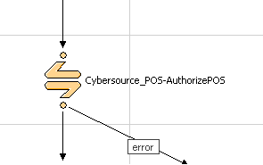

This required call node should be integrated at EACreditCard-Authorize pipeline of DSS app as show below. The track data, expiration date or account number should not be encrypted and may need to be decrypted prior to calling Cybersource_POS-AuthorizePOS depending on the payment terminal used.
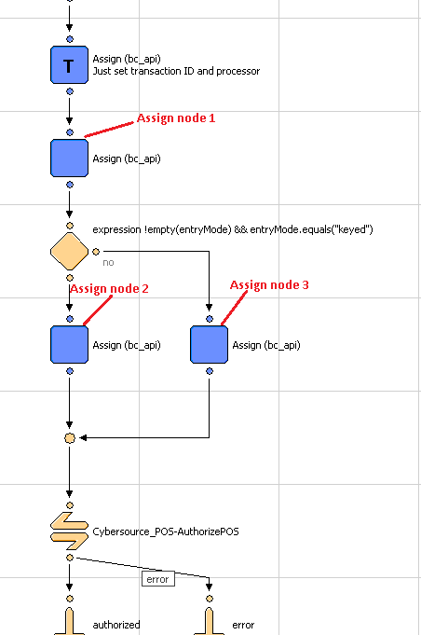
Three assign nodes must be used for required node Cybersource_POS-AuthorizePOS to work correctly as shown above. The assign node must set variables based on POS terminal entry mode. Below are the use and description for assignment of variables. Assuming that object.attribute variable used in Assign node will be replaced by actual object/variable to get the required values:
POS terminal entry mode can be set in int_ocapi_ext/cartridge/scripts/actions/CaptureCreditCardDetails.ds as shown below.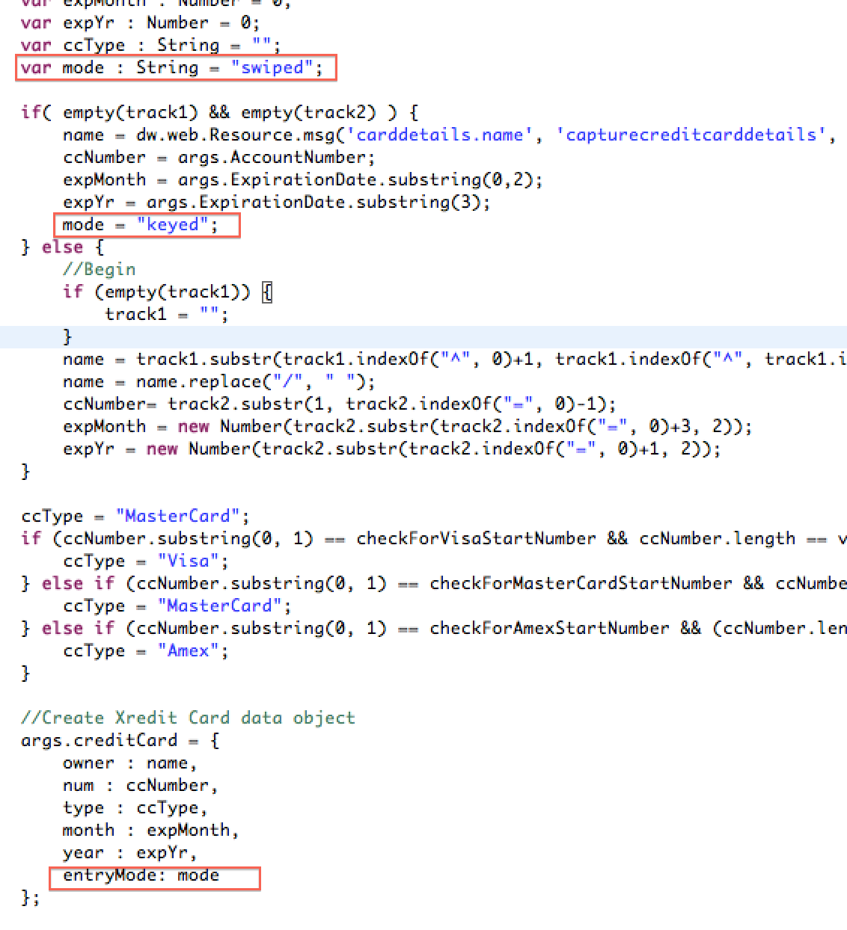
1. Use of Assign node labeled as “Assign node 1” above. This will set the common variables for the transaction irrespective of entry mode used. Below is the screenshot of variables used in this assign node:
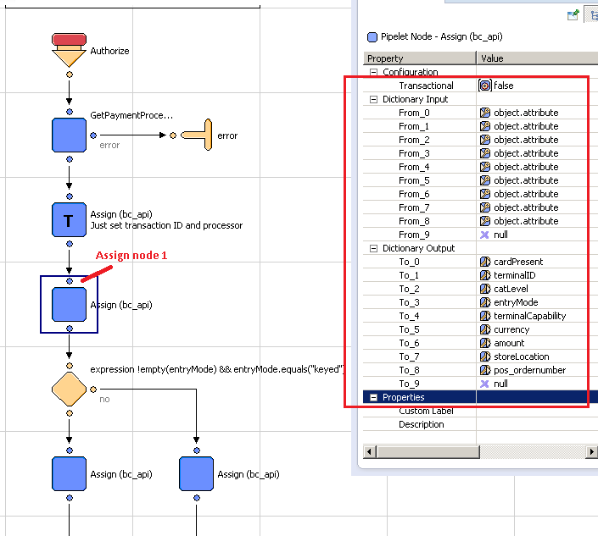

Example input variables from DSS:
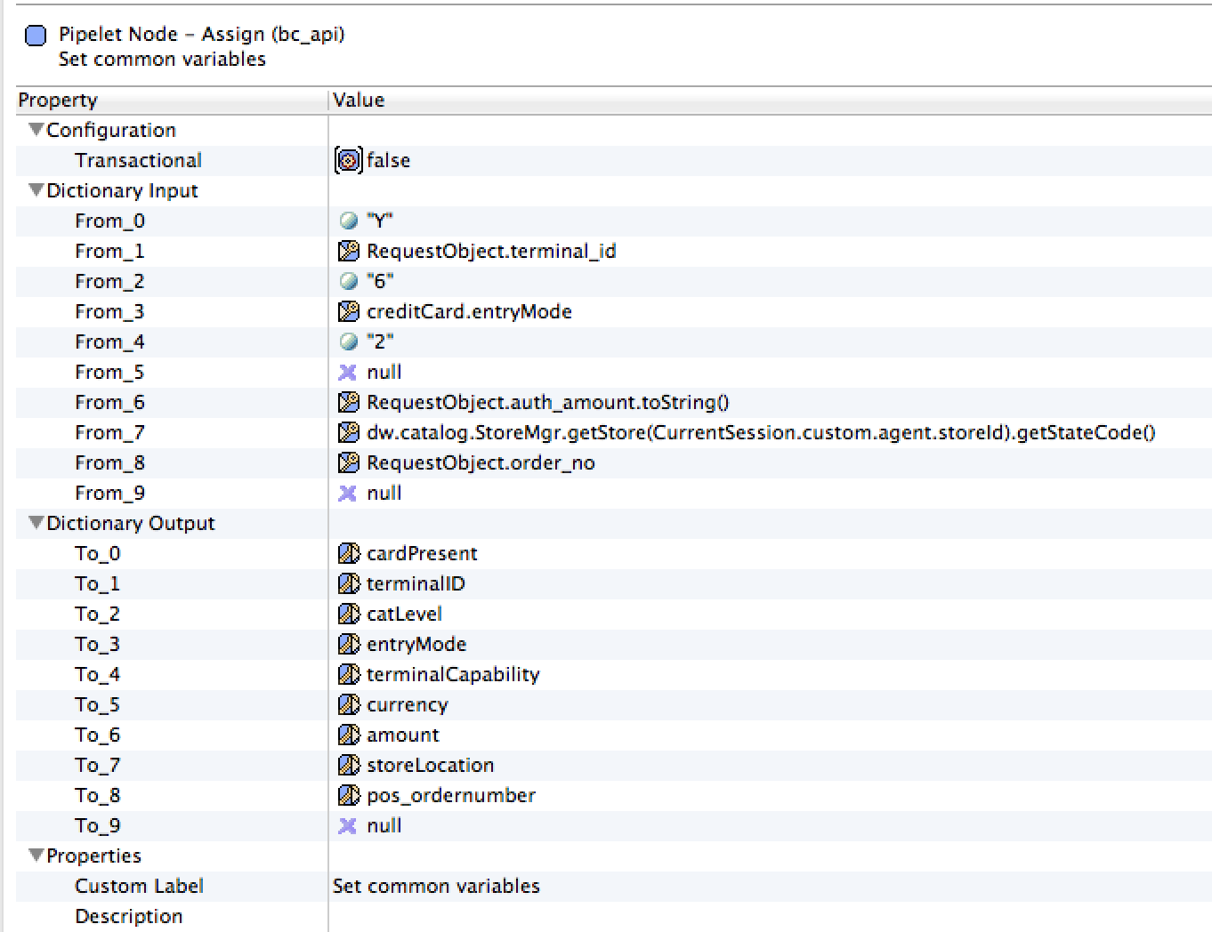
2. Use of Assign node labeled as “Assign node 2” if keyed entry mode is used on the POS terminal device. See below screenshot for the list of variables to set:
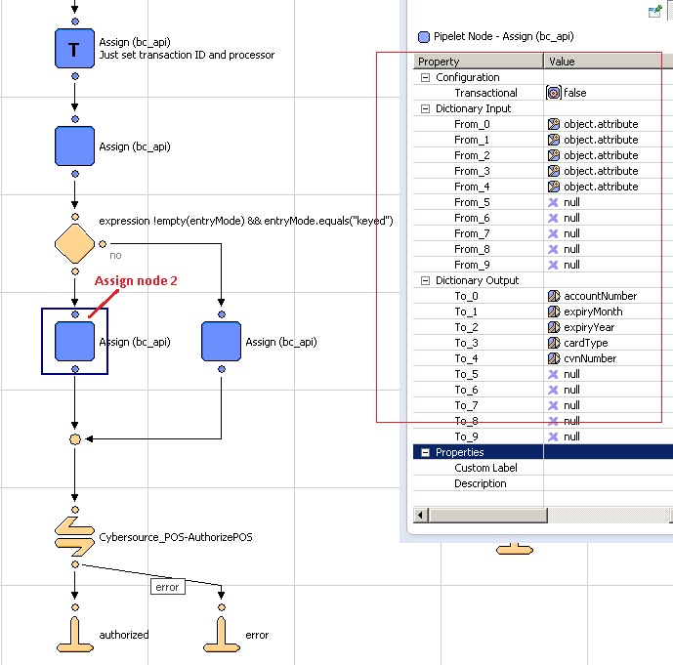

Example input variables from DSS:

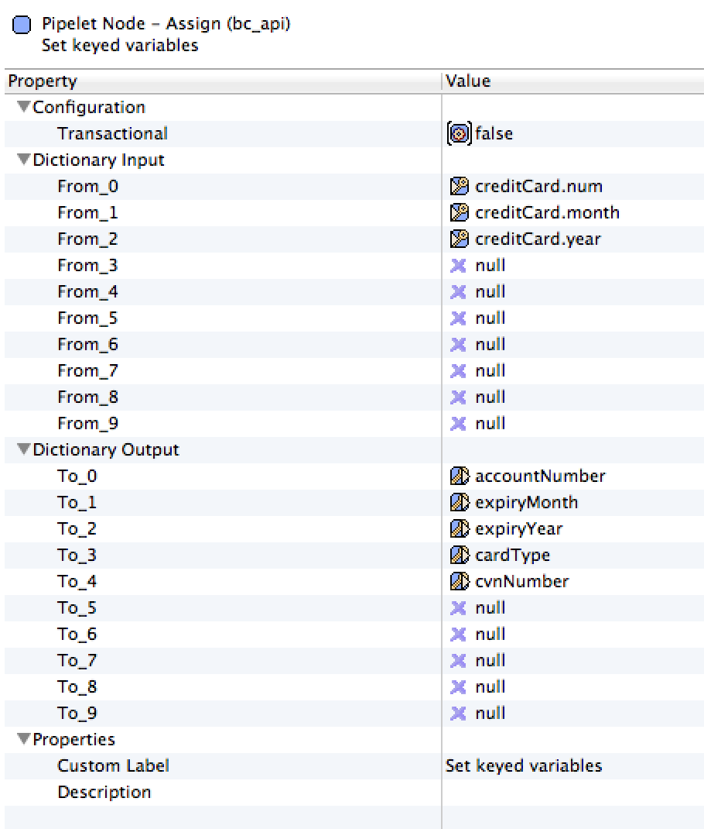
- Use of Assign node labeled as “Assign node 3” if swiped entry mode is used on the POS terminal device. See below screenshot for the variable to set:
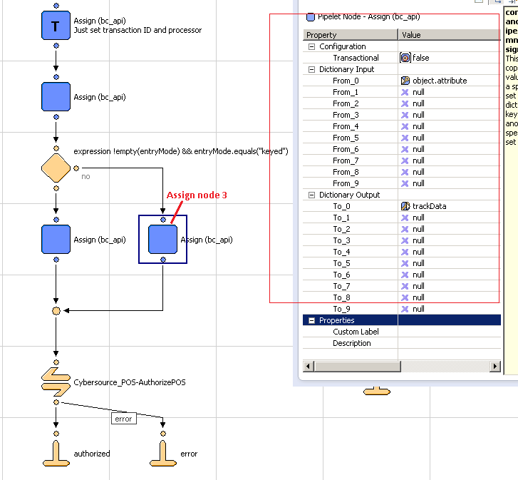

Example of input variables from DSS: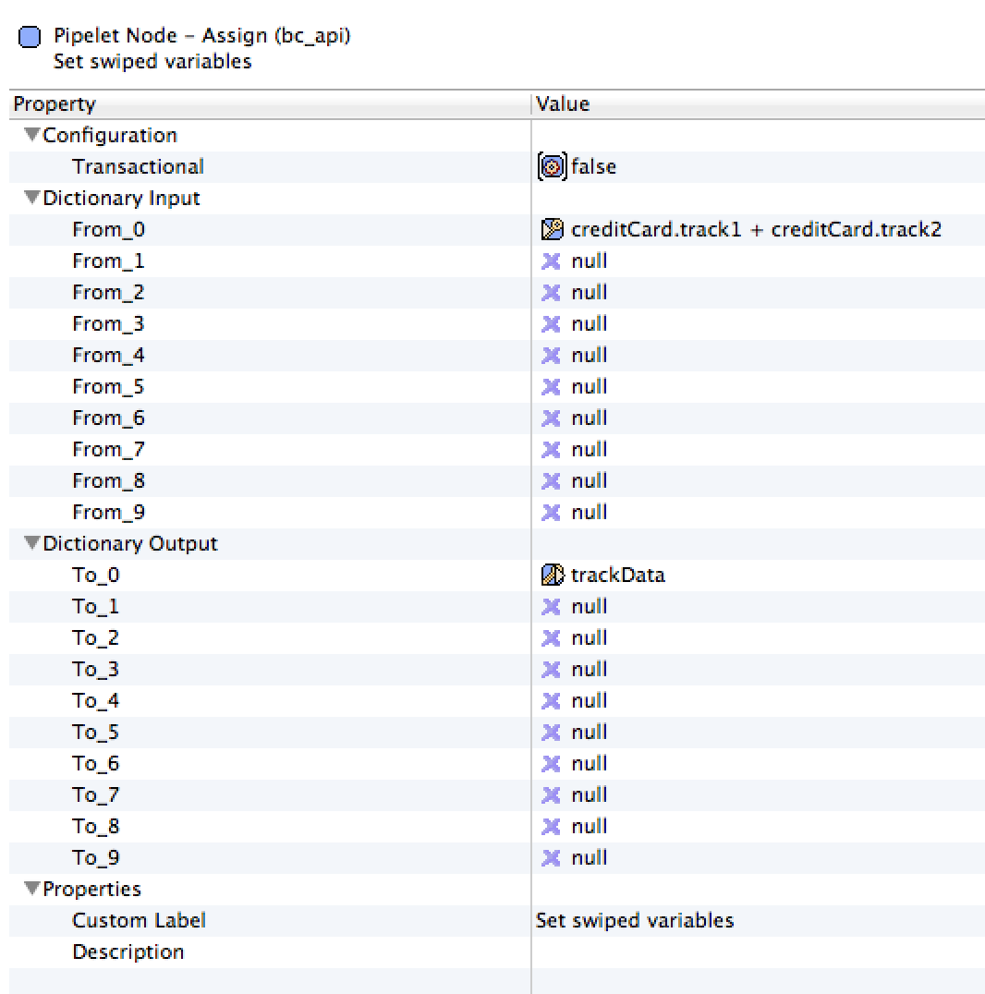

Below is the snapshot of required pipeline.
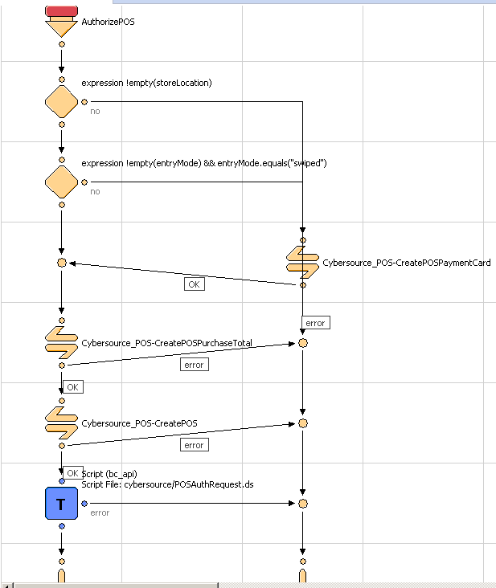

Below is the list of variables with description. One or two variables become mandatory depending upon other variables and few are optional:
S. No. | Variable name | Description | Note
1 | cardPresent | Indicates whether the card is present at the time of retail POS transaction. Possible values:  N – card not present  Y – card is present | Required.
2 | catLevel | Type of cardholder activated terminal. Possible values:  1 – Automated dispensing machine  2 – Self-service terminal  3 – Limited amount terminal  4 – In-flight commerce (IFC) terminal  5 – Radio frequency device  6 – Mobile acceptance terminal | Optional. This variable becomes required if terminalID variable is set to a value.
3 | entryMode | Method of entering credit card information into the POS terminal. Possible values:  keyed – Manually keyed into POS terminal.  swiped – Read from credit card magnetic stripe. | Required.
4 | terminalCapability | POS terminal’s capability. Possible values:  1 – Terminal has a magnetic stripe reader only.  2 – Terminal has a magnetic stripe reader and manual entry capability.  3 – Terminal has manual entry capability only. | Required.
5 | terminalID | Identifier for the terminal at your retail location. You can define this value yourself, but consult with the processor for requirements. Terminal ID(s) are configurable in a custom object named ‘POS_TerminalMapping’ (Refer custom object definition XML to be impoorted). Here terminal device’s serial number will be mapped to a Terminal ID. This variable should be assigned device’s serial number. Code will pick configured Terminal ID if found and passed to CyberSource API in request. | Optional.
6 | trackData | Card’s track 1 and 2 data. Some processors require track 1 data, some processors require track 2 data, and some processors require both track 1 data and track 2 data. To make sure that you provide the required information regardless of the processor that you use now or may use in the future, CyberSource recommends that you send both track 1 and track 2 data in your retail POS requests.  The sentinels are required. The start sentinel (%) indicates the initial data position on the track. The end sentinel (?) follows the final character of data recorded on the track. Details of track 1 and track 2 data for the example %B4111111111111111^SMITH/JOHN^1612101976110000868000000?;4111111111111111=16121019761186800000?  Track 1 – the track 1 data precedes the semicolon (;)  Track 2 – the track 2 data follows the semicolon (;) | Required if entryMode=swiped.
7 | currency | Currency used for order. For possible values refer ISO Standard Currency Codes | If this variable is not set with any currency code then default currency code is retrieved configured for web store in Business Manager.
8 | amount | Grand total for the order.
9 | accountNumber | Customer’s credit card number. | This variable becomes mandatory if entryMode=keyed.
10 | cardType | Type of card to authorize. Possible values:  001 – Visa  002 – MasterCard  003 – American Express  004 – Discover  005 – Diners Club  006 – Carte Blanche  007 – JCB | CyberSource strongly recommends that you send the card type even when it is optional for your processor and card type. Omitting the card type can cause the transaction to be processed with the wrong card type.
11 | cvnNumber | This number is never transferred during card swipes. | Optional.
12 | expiryMonth | Two-digit month in which credit card expires. Format: MM. Possible values: 01 through 12. Leading 0 is required. | Required if entryMode=keyed.
13 | expiryYear | Four-digit year in which credit card expires. Format: YYYY. | Required if entryMode=keyed.
14 | storeLocation | Store’s physical location. This is use to configure merchant’s ID and security key in a custom object to call CyberSource API for the transaction. This is dependent upon merchant how they wanted to link store(s) to Merchant ID (MID). For e.g. if merchant has 3 separate CyberSource merchant ID and want to use one MID for store(s) in Massachusetts, 2nd MID for store(s) in New York City, etc. then assign this variable as MA or Massachusetts or any string representing the location AND configure the same value as POS Location field for POS_MerchantIDs custom object in Business Manager after import. | Location can be set as State code or Zip code or city etc. For e.g. MA (Massachusetts) or  01803 (Burlington, MA) or  Burlington
15 | pos_ordernumber | Order number for the transaction needs to be set to this variable | Required

In order to obtain messages in DSS based on failures from Cybersource changes will need to be made to int_cybersource/cartridge/scripts/cybersource/POSAuthRequest.ds in order to output a Status. Add a @output Status : dw.system.Status to the beginning comment of the file and then set the following Status values:

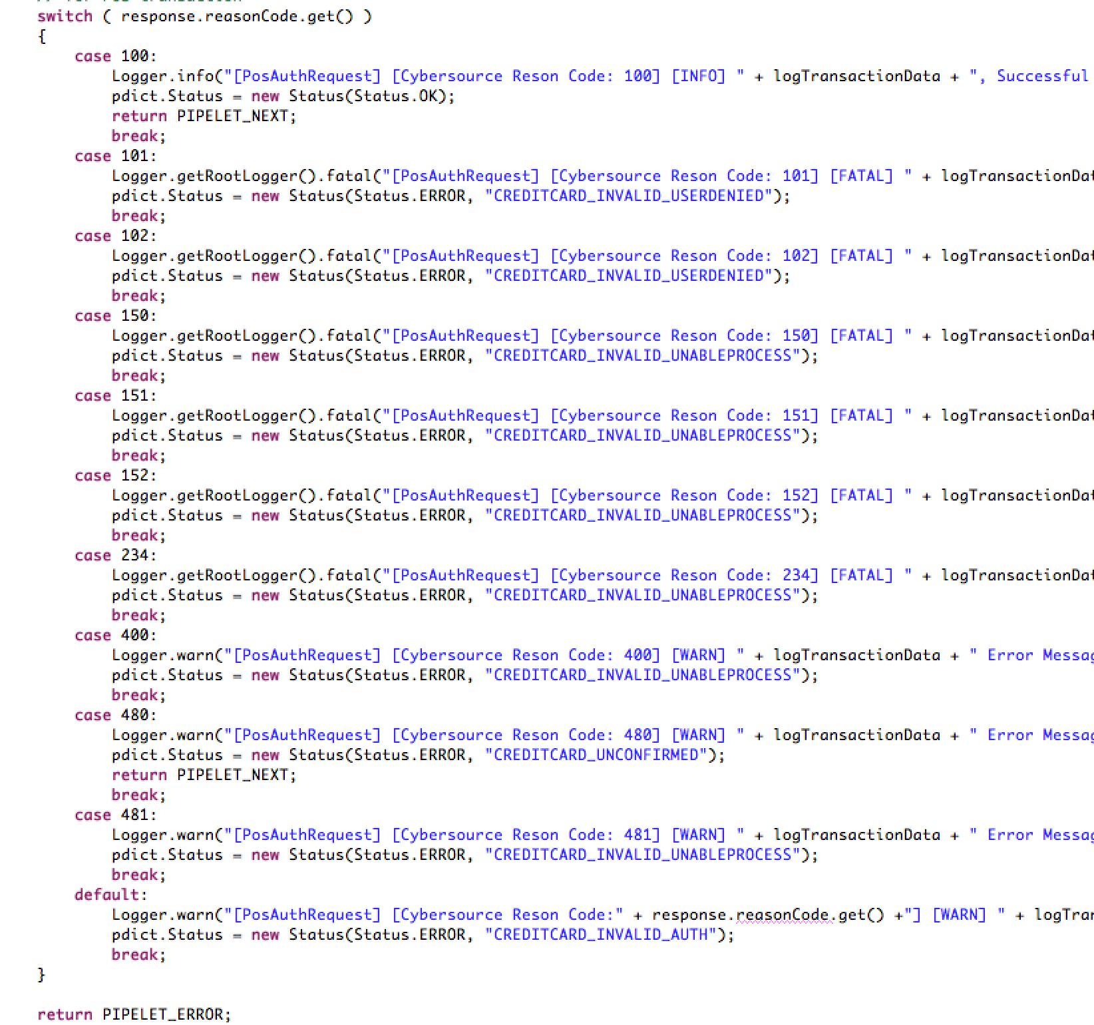

Then add these lines to the int_ocapi_ext/cartridge/templates/resources/eastatus.properties file
CREDITCARD_INVALID_USERDENIED=400|InvalidCreditCardExpception|User Denied|User has been denied.
CREDITCARD_INVALID_AUTH=400|InvalidCreditCardException|Credit Card Declined|Authorization Denied.
CREDITCARD_INVALID_UNABLEPROCESS=400|InvalidCreditCardException|Unable to Process|Call Customer Service.
CREDITCARD_UNCONFIRMED=400|InvalidCreditCardException|Unconfirmed|Unconfirmed

In the Cybersource_POS cartridge set the Status to the CreditCardStatus

Site Configuration

Import Meta Data
Import following site configuration meta-data through Business Manager:
- /int_cybersource/configuration/metadata/Cybersource-metadata.xml – sets all the site preferences

- /int_cybersource/configuration/metadata/Cybersource_PaymementTransaction_updates.xml – add custom attributes to the Payment transaction object.

- /int_cybersource/configuration/metadata/Cybersource_subscription_metadata.xml – add custome attributes to the CustomerPaymentInstrument and OrderPaymentInstrument object
- /int_cybersource/configuration/Vme_Payment_Method.xml – add new payment method as VISA_VME
- /int_cybersource/configuration/Vme_Metadata.xml – set all site preferences for VISA_VME
- /int_cybersource/configuration/CyberSource_POS_CustomObjectDefinitions.xml – add 2 custom objects for mapping of device’s serial number to Terminal ID and set of Merchant ID and key pair(s).

The following Business Manager Screenshot depicts the import / Export functionality:
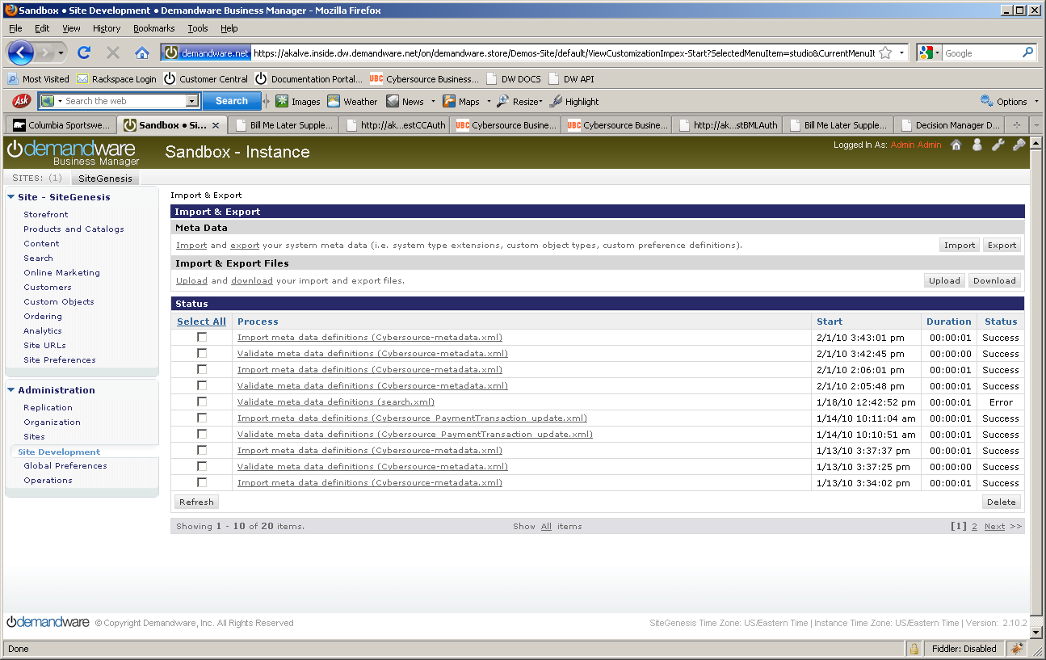

Configure Site Preferences
Update CyberSource site preference through Business Manager >StoreFront Site> Site Preferences.
The screen shot below depicts the site preferences configuration:
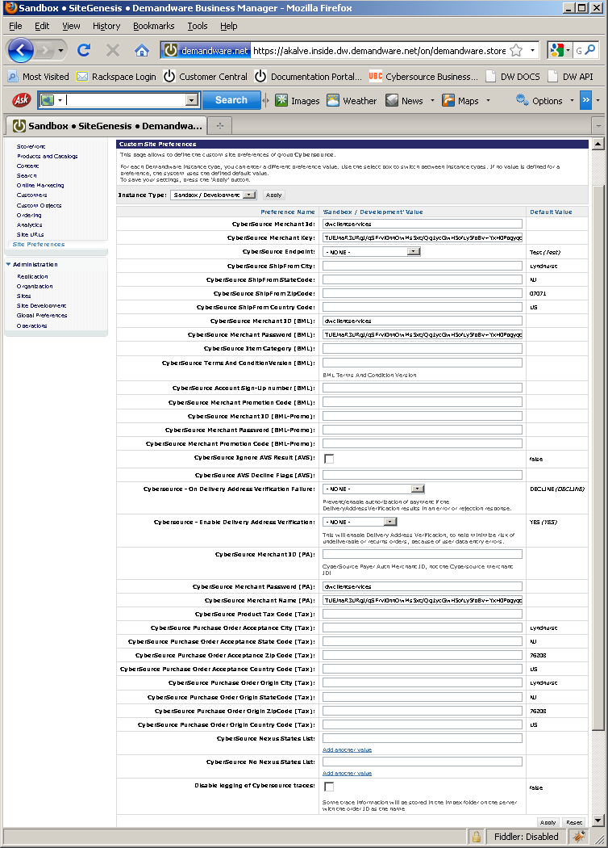….
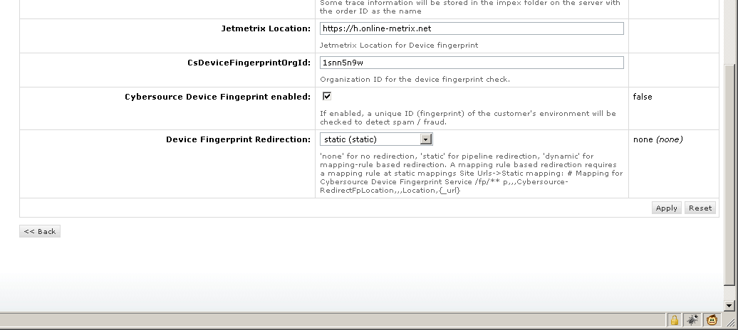

Update credit card preference through Business Manager >StoreFront Site> Ordering> Payment Methods> Credit Card/Debit Cards > Enable Payer Authentication
The screen shot below depicts the site preferences configuration:
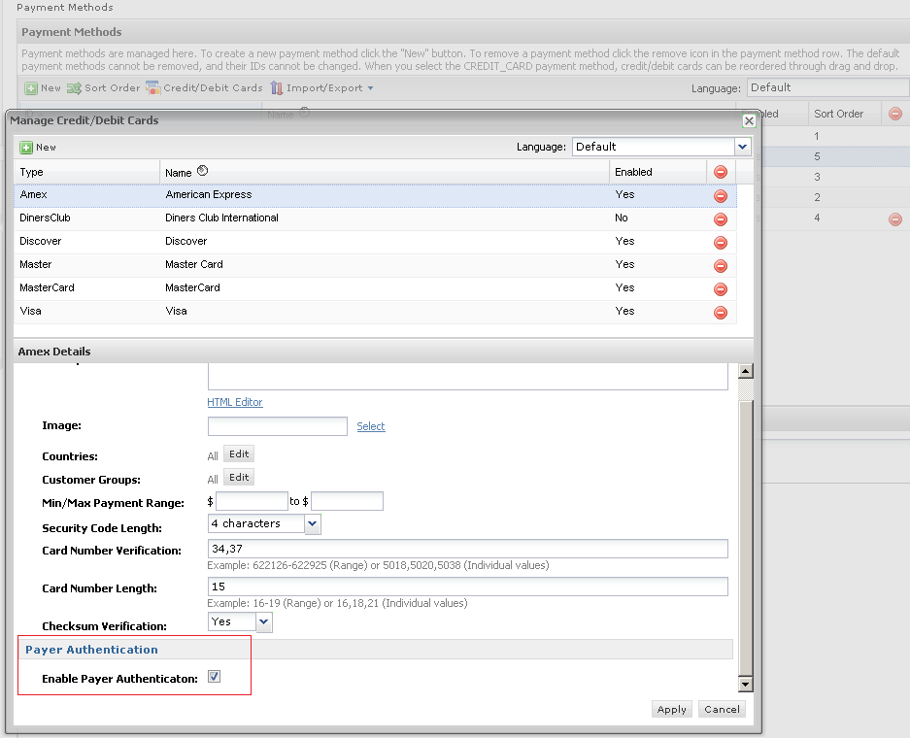

Update shipping method preference through Business Manager >StoreFront Site> Ordering> Shipping Methods > Name > Cybersource Shipping ID
The screen shot below depicts the site preferences configuration:
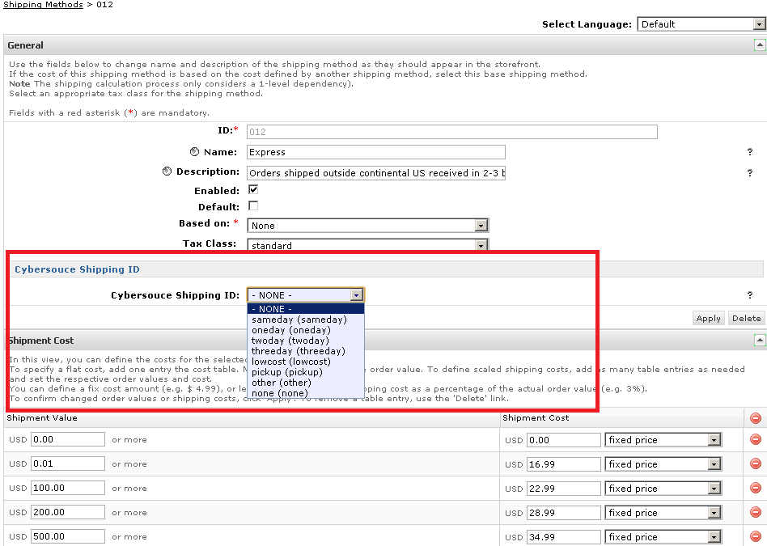

Configure Site Preferences for V.me
Verify VISA_VME as newly added Custom Preferences Group

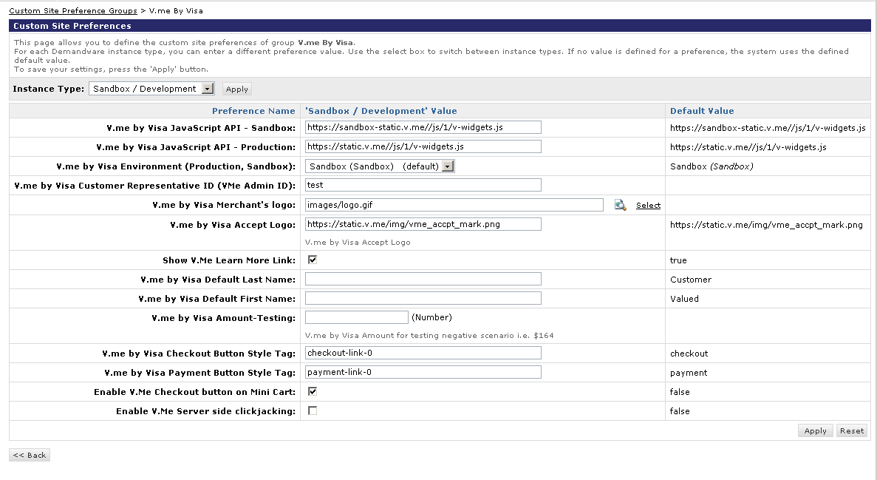

Applying CyberSource Cartridge to the Site

Go to the “Administration” in the left hand list to expand the menu and select Sites > Manage Sites link. This will open a list of the active sites on the Demandware platform in your account. Click on the site for which you wish to add the CyberSource cartridge. This will open the General Settings page for that site.
Add int_cybersource cartridge to the cartridge path as depicted in the following screen:

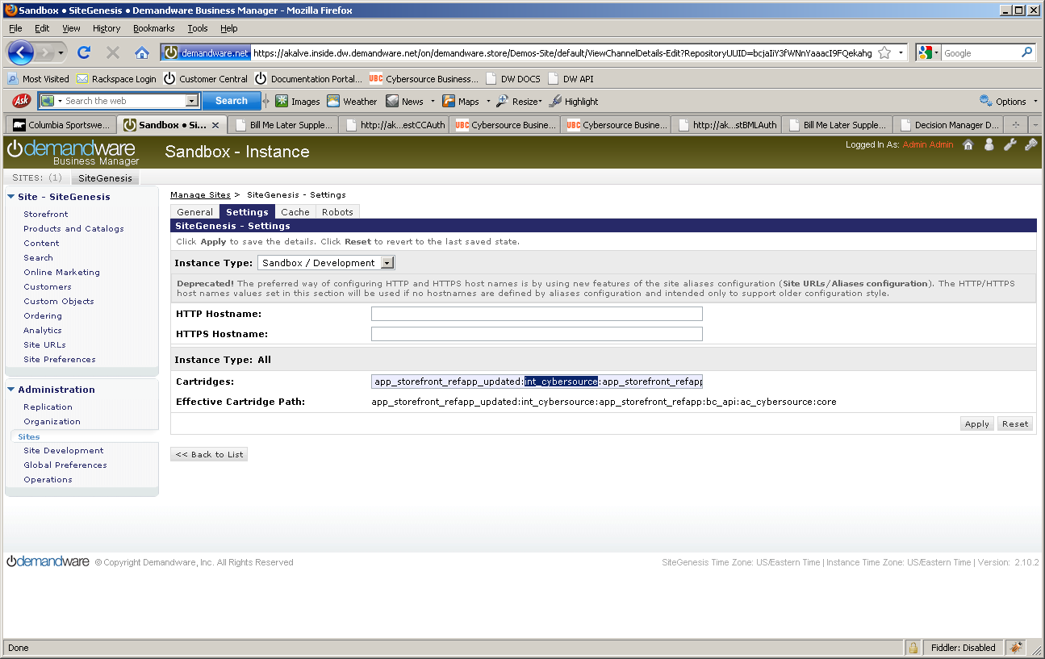

Applying V.me Cartridge to the Site
Go to the “Administration” in the left hand list to expand the menu and select Sites > Manage Sites link. This will open a list of the active sites on the Demandware platform in your account. Click on the site for which you wish to add the V.me cartridge. This will open the General Settings page for that site.
Add int_visa_VME cartridge to the cartridge path as depicted in the following screen:
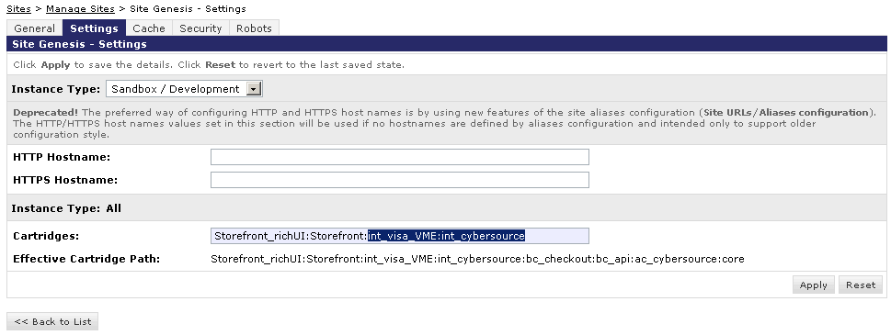

Configure Custom Objects for Retail POS
Two custom objects have been added for POS transactions. Below are screenshots of sample custom object entry for both custom objects:
  - POS_MerchantIDs
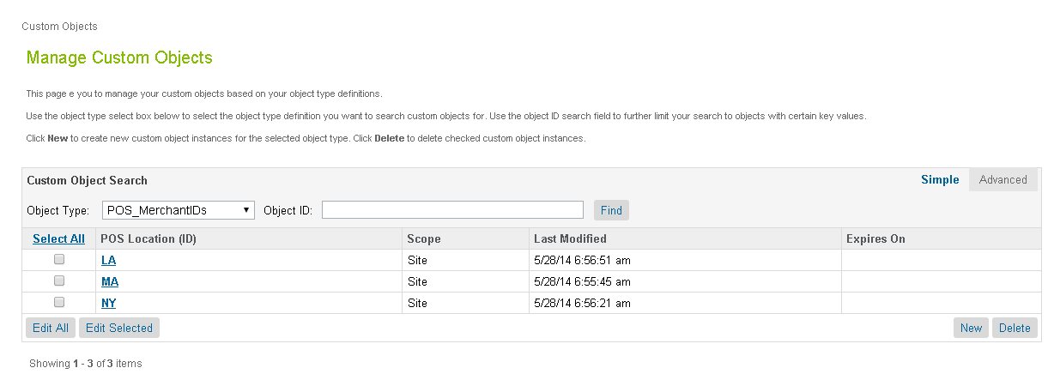
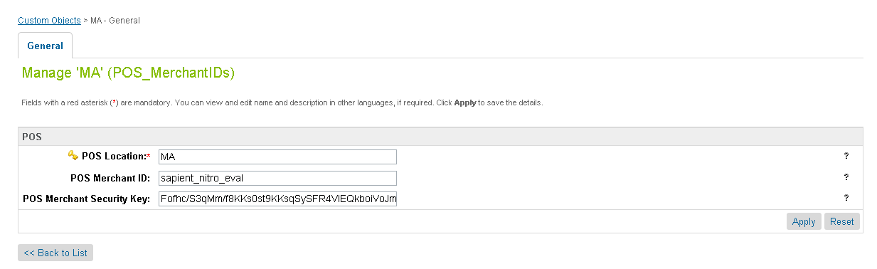
  - POS_TerminalMapping
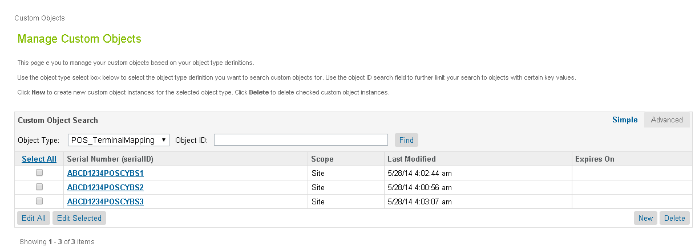
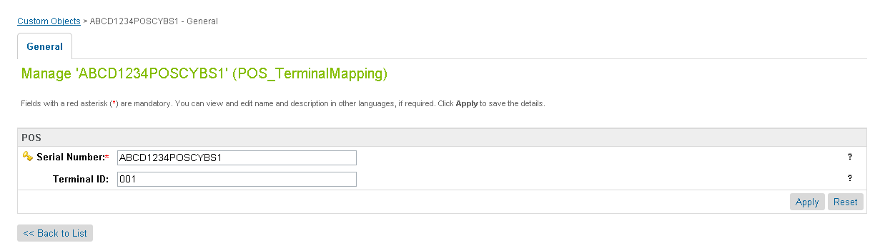

Testing
Use CybersourceUnitTest pipeline to test all the services as follows:

Authorize Credit Card
Use and modify the CybersourceUnitTest-TestCCAuth pipeline and associated scripts and sub-pipelines. The end node of the unit test pipeline is a template which displays all relevant request/response information in an easy to digest manner. User can change static credit card and address data to observe various responses.
Note: Mark the start node as “PUBLIC” before executing the test case

Tax Service
Use and modify the CybersourceUnitTest-TestTax pipeline and associated scripts and sub-pipelines. The script nodes for creating CreateCybersourceShipTo and CreateCybersourceBillTo objects have bindings to produce valid results, but otherwise can be manually modified to test against any domestic or international address.
The end node of the unit test pipeline for taxes is a template which displays all relevant request/response information in an easy to digest manner, to aid the debugging the various response codes and corrected address response.
Note: Mark the start node as “PUBLIC” before executing the test case

Address Verification Service (AVS)
Use and modify the CybersourceUnitTest-TestCCAuth pipeline and associated scripts and sub-pipelines. By running simplified payment authorizations with different site preferences set, you can see how the AVS process works and how that result affects the overall payment authorization process.
Note: Mark the start node as “PUBLIC” before executing the test case

Delivery Address Verification Service (DAV)
To test the stand-alone DAV service, use and/or modify the CybersourceUnitTest-TestDAVCheck pipeline and associated scripts and sub-pipelines. Like other test pipelines,test data can be customize to simulate various situations that need to be handled.
Note: Mark the start node as “PUBLIC” before executing the test case
The end node of the unit test pipeline for the stand-alone DAV Service is a template which displays all relevant request/response information in an easy to digest manner, to aid the debugging the various response codes and corrected address response.
Note: Mark the start node as “PUBLIC” before executing the test case

Payment Tokenization
Use the Cybersource_Subscription-Start pipeline to start Subscription creation test suite. By entering test data you can use the various Payment Tokenization related services like Create Subscription, View Subscription, Update Subscription, Delete Subscription, Use Subscription for One Time Payment.
Note: Mark the start node as “PUBLIC” before executing the test case

Full Authorization reversal
Use the Cybersource_Services-Start pipeline to start Authorization reversal test suite. By entering test data merchant can use the Cybersource Full Authorization Reversal service.
Note: Mark the start node as “PUBLIC” before executing the test case

Device Fingerprint
Call the pipelineCybersourceUnitTest-TestFingerprintto test the device Fingerprint Service. ACreditCard Authorization is done and a device fingerprint will be additionally submitted.
Note: Mark the start node as “PUBLIC” before executing the test case

Payer Authentication
Call the pipeline CybersourceUnitTest-TestPA to test the Payer Authentication Service.
Note: Mark the start node as “PUBLIC” before executing the test case

V.me Authorization
Call the pipeline CybersourceUnitTest-TestVmeAuth to test the V.me Authorization Service.
Note: Mark the start node as “PUBLIC” before executing the test case

V.me Get Checkout Details
Call the pipeline CybersourceUnitTest-TestVmeGetCheckoutDetails to test the V.me Get Checkout Details Service.
Note: Mark the start node as “PUBLIC” before executing the test case

V.me Confirm Purchase
Call the pipeline CybersourceUnitTest-TestVmeConfirmPurchase to test the V.me Confirm Purchase Service.
Note: Mark the start node as “PUBLIC” before executing the test case

V.me Authorization Reversal
Call the pipeline CybersourceUnitTest-TestVmeAuthReversalRequest to test the V.me Authorization Reversal Service.
Note: Mark the start node as “PUBLIC” before executing the test case

V.me Capture
Call the pipeline CybersourceUnitTest-TestVmeCaptureRequest to test the V.me Capture Service.
Note: Mark the start node as “PUBLIC” before executing the test case

V.me Refund
Call the pipeline CybersourceUnitTest-TestVmeRefundRequest to test the V.me Refund Service.
Note: Mark the start node as “PUBLIC” before executing the test case

V.me Initiate Request
Call the pipeline CybersourceUnitTesting-TestVmeInitiateService to test the V.me Initiate Service.
Note: Mark the start node as “PUBLIC” before executing the test case

Retail POS Authorization Request
Call the pipeline CybersourceUnitTesting-StartPOS to test the retail POS Service. This renders a template with a form containing various request fields to enter/select values. The service response is shown after the submit button is clicked. The field’s label turns to red colored font if the field was mandatory.
Note: Mark the start node as “PUBLIC” before executing the test case

Cartridges Structure and Reference

Pipelines

Cybersource
This contains the nodes that make the actual call to CyberSource based on what is needed, cc auth, bml, tax or address verification.

CybersourceData
This contains the node that creates the objects needed for the CyberSource pipeline. Each node in the pipeline creates a needed object for each request. This is the pipeline that will be modified by customers, as each customer may need to pass different information based on their needs

CybersourceUnitTesting
Used for testing.

Cybersource_Subscription
This contains the nodes that makes call to different Subscription related services. This is the pipeline that will be referred and modified by the merchants, as each merchant may need to pass different information based on their needs.

Cybersource_POS
This contains the main node to be integrated and related sub node for integration of retail POS transaction. This pipeline also contains other node for testing purpose.

Scripts
There is a JS object for each request data elements. List of DS objects used:
- Cybersource_BillTo_Object.ds
- Cybersource_BML_Object.ds
- Cybersource_Card_Object.ds
- Cybersource_Item_Object.ds
- Cybersource_PurchaseTotals_Object.ds
- Cybersource_ShipFrom_Object.ds
- Cybersource_ShipTo_Object.ds
- Cybersource_TaxRequest_Object.ds
- CreateCyberSourceBillToObject_UserData.ds
- CreateCyberSourcePaymentCardObject_UserData.ds
- CreateCyberSourcePurchaseTotalsObject_UserData.ds
The following scripts are used in CyberSource pipeline to make the CyberSource web service calls.
- TaxationRequest.ds
- BMLAuthRequest.ds
- CCAuthRequest.ds
- DAVRequest.ds
- PayerAuthEnrollCheck.ds
- PayerAuthValidation.ds

The following scripts are used in Cybersource_Subscription pipeline to make the Payment Tokenization web service calls.
- CreateSubscription.ds
- DeleteSubscription.ds
- OnDemandSubscription.ds
- UpdateSubscription.ds
- ViewSubscription.ds
The following scripts are used to create the objects needed. These are the scripts that customers would change to fit their needs
- CreateCybersourceBillToObject.ds
- CreateCybersourceBMLObject.ds
- CreateCybersourceBMLPaymentCardObject.ds
- CreateCybersourcePaymentCardObject.ds
- CreateCybersourcePurchaseTotalsObject.ds
- CreateCybersourceShipFromObject.ds
- CreateCybersourceShipToObject.ds
- CreateCybersourceTaxationItemsObject.ds
- CreateCybersourceTaxationPurchaseTotalsObject.ds
- CreateCyberSourceTaxRequestObject.ds

These are the pipelines that use the scripts from above and may have need storefront specific integration:
- CybersourceData:CreateBillTo
- CybersourceData:CreateShipTo
- CybersourceData:CreatePaymentCard
- CybersourceData:CreatePurchaseTotals
- CybersourceData: CreateShipFrom
- CybersourceData: CreateTaxItems
- CybersourceData: CreateTaxService

The following is a library script that is used by the Request scripts to build the XML request that is passed to Cybersource. This lib script contains integration independent code and it doesn’t need any storefront specific changes.
libCybersource.ds

Templates
- payerauthentication.isml
- payerauthenticationredirect.isml
- pt_payerauthentication.isml
- Contains templates used by unit test pipeline

Configuration Files
Contains two configuration file as follows:
- Cybersource_PaymentTransaction_update.xml
Contains custom attributes added to the “PaymentTransaction” object.
- Cybersource-metadata.xml
Contains CyberSource specific site preferences.

V.me Cartridge Structure
Code for V.me functionalityis structured in two different cartridges:
- int_visa_VME
  - This cartridge constitutes changes required to the Storefront level e.g. adding V.me Buy button, Pipelines to process V.me as payment instrument.
Component | Files
Pipelines | COShippingVisa  Hashing  VISA_VME
Forms | vme.xml  vMeBilling.xml
Scripts | ValidateCartForCheckout.ds  CreatePaymentInstrument.ds  CreateShipmentShippingAddress.ds  libStringUtilsExt.ds  UpdateFormInformation.ds  Utils.ds  CheckoutDetailObject.ds  hash.ds  HashUtils.ds  SetResponseHeader.ds
Templates | hash.isml  shippingResponse.isml  visa_buy.isml  visa_callback.isml  visa_form.isml  visa_init.isml  visa_modules.isml  visa_root.isml
Properties File | int_visa_VME.properties
Sample Files | Cart_sample.xml  COBilling_sample.xml  billing_sample.isml  minibillinginfo_sample.isml  paymentmethods_sample.isml  orderdetails_sample.isml  orderdetailsemail_sample.isml  modules_sample.isml  cart_sample.isml  app_sample.js

Retail POS Cartridge Components
Component | Files
Pipelines | Cybersource_POS.xml  CybersourceUnitTesting.xml
Forms | pos.xml
Scripts | cybersource/Cybersource_POS_Object.ds  cybersource /libCybersource.ds  cybersource/POSAuthRequest.ds  POS/CreateCyberSourcePaymentCardObject_UserData.ds  POS/CreateCyberSourcePOSObject_UserData.ds  POS/CreateCyberSourcePurchaseTotalsObject_UserData.ds  Cybersource_UnitTesting/TestPOSAuth.ds
Templates | custom/pos_scripterror.isml  pos/createpos.isml  pos/postransactionresult.isml
Metadata | CyberSource_POS_CustomObjectDefinitions.xml

Typical Project Plan

Roles, Responsibilities
Typically most of the integration works is done by the backend developer. We expect that the person doing this integration is familiar with the web service, xml processing and has hands on experience with the Demandware platform.

Typical Efforts and Timelines
The level of effort is mostly detected by the services merchant may choose from the CyberSource cartridge. The
CyberSource Service | Level of Effort (LOE) | Dependencies
Initial Cartridge Setup | 0.5– Person Day  List of tasks involved:  - Add CyberSource Cartridge to the project  - Import Cybersource-metadata.xml  - Import Cybersource_PaymentTransaction_update.xml | - Cartridge is available
Authorize Credit Card | 0.5– Person Day  List of tasks involved:  - Integrate CyberSource-AuthorizeCreditCard pipeline with COPlaceOrder. | - Merchant ID and Key is established for the client.  - Site Preferences for authorization configured with above ID and Key.
Device Fingerprint (as addition to Authorize Credit Card) | 0.5 Person Day | - Enable Device Fingerprint, set Organization ID  - Add include at billing page.
Address Verification Service (AVS)* | 0.5– Person Day | - Initial Cartridge Setup
Delivery Address Verification (DAV)* | 0.5– Person Day | - Initial Cartridge Setup
Bill Me Later (BML) | 0.5– Person Day | - Setup Account with Bill Me Later.
Decision Manager | 0.5– Person Day | - Access to Decision Manager.  - Business rules are defined.  - Order status notification URL pointing to Cybersource-NewDecision pipeline is defined.
Payment Tokenization* | 0.5– Person Day  +  Depends on customization needs | - Initial Cartridge Setup
Payer Authentication | 1.5– Person Day | - Initial Cartridge setup  - Update CoPlaceOrder-HandlePayments pipeline  - Handle error scenarios in merchant specific ways
V.me Initial Cartridge setup | 0.5– Person Day | - Cartridge is available  - Merchant account on CyberSource servers is setup for V.me integration
V.me integration on Cart Page | 1.0– Person Day | - Initial Cartridge Setup
V.me integration on Payment Page | 1.0– Person Day | - Initial Cartridge Setup

*Note that because customized user interface elements are completely dependent on merchant specification, the time required to interact with the customer to correct address information or confirm standardized address format corrections, is not included; only the time required to integrate with the web services is included, with minimal testing and simplified validation handling, ie. Automatically make correction to a customer address, as per validation response.

Pre Production Steps
In order to avoid misuse of unit testing pipelines on production instances it is advised to make following pipelines private before pushing code to production instances.
CybersourceUnitTesting-TestBMLAuth
CybersourceUnitTesting-TestCCAuth
CybersourceUnitTesting-TestTax
CybersourceUnitTesting-TestDAVCheck
CybersourceUnitTesting-TestPA
CybersourceUnitTesting-TestFingerprint
Cybersource_Subscription-Start
Cybersource_Subscription-CreateSubscription
Cybersource_Subscription-ViewSubscription
Cybersource_Subscription-UpdateSubscription
Cybersource_Subscription-DeleteSubscription
Cybersource_Subscription-OnDemandPayment
Cybersource_Services-Start
Cybersource_Services-Reversal

CybersourceUnitTesting-TestVmeAuth
CybersourceUnitTesting-TestVmeGetCheckoutDetails
CybersourceUnitTesting-TestVmeConfirmPurchase
CybersourceUnitTesting-StartVme
CybersourceUnitTesting-TestVmeAuthReversalRequest
CybersourceUnitTesting-TestVmeCaptureRequest
CybersourceUnitTesting-TestVmeRefundRequest
CybersourceUnitTesting-TestVmeInitiateService
CybersourceUnitTesting-StartPOS

CyberSource Site Preferences

Site preference and description
Site Preferences | Description
CyberSource Merchant Id(CsMerchantId) | CyberSource Merchant ID
CyberSource Merchant Key(CsSecurityKey) | CyberSource Security Key
CyberSourceEndpoint(CsEndpoint) | CyberSource Web service End points:  Test https://ics2wstest.ic3.com/commerce/1.x/transactionProcessor  Prodhttps://ics2ws.ic3.com/commerce/1.x/transactionProcessor
CyberSourceShipFromCity(CsShipFromCity) | Ship to data if fixed for the site
CyberSourceShipFromStateCode(CsShipFromStateC)ode | Ship to data if fixed for the site
CyberSourceShipFromZipCode(CsShipFromZipCode) | Ship to data if fixed for the site
CyberSourceShipFrom Country Code(CsShipFromCountryCode) | Ship to data if fixed for the site
CyberSource Merchant ID(CsBmlMerchantId) | BML Merchant ID
CyberSource Merchant Password(CsBmlPassword | BML Merchant Key
CyberSource Item Category(CsBmlItemCategory) | BML Item Category
CyberSource Terms AndConditionVersionCsBmlTCVersion | BML Terms and Condition Version
CyberSource Account Sign-Up numberCsBmlNewAcctNo) | BML CyberSource account sign-up number
CyberSource Merchant Promotion Code(CsBmlPromoCode) | BML promo code
CyberSource Merchant ID(CsBmlPromoMerchantId) | BML promo merchant ID
CyberSource Merchant Password(CsBmlPromoMerchantPassword) | BML promo merchant key
CyberSource Merchant Promotion Code(CsBmlPromoPromoCode) | BML promo promo code
CyberSource Ignore AVS Result(CsAvsIgnoreResult) | AVS ignore results

CyberSource AVS Decline Flags(CsAvsDeclineFlags)

Cybersource – On Delivery Address Verification Failure(CsDavOnAddressVerificationFailure)
Cybersource – Enable Delivery Address Verification(CsDavEnable) | This will enable Delivery Address Verification, to help minimize risk of undeliverable or returns orders, because of user data entry errors.
CyberSource Merchant ID(CsPaMerchantId) | Payer Auth merchant ID
CyberSource Merchant Password(CsPaMerchantPassword) | Payer Auth Merchant Key
CyberSource Merchant Name(CsPaMerchantName) | Name
CyberSource Purchase Order Acceptance City(CsPoaCity) | CyberSource purchase order acceptance data – used by Tax
CyberSource Purchase Order Acceptance State Code(CsPoaStateCode) | CyberSource purchase order acceptance data – used by Tax
CyberSource Purchase Order Acceptance Zip Code(CsPoaZipCode) | CyberSource purchase order acceptance data – used by Tax
CyberSource Purchase Order Acceptance Country Code(CsPoaCountryCode) | CyberSource purchase order acceptance data – used by Tax
CyberSource Purchase Order Origin City(CsPooCity) | CyberSource purchase order origin data – used by Tax
CyberSource Purchase Order Origin StateCode(CsPooStateCode) | CyberSource purchase order origin data – used by Tax
CyberSource Purchase Order Origin ZipCode(CsPooZipCode) | CyberSource purchase order origin data – used by Tax
CyberSource Purchase Order Origin Country Code(CsPooCountryCode) | CyberSource purchase order origin data – used by Tax
CyberSource Nexus States List(CsNexus) | CyberSource nexus state list
CyberSource No Nexus States List(CsNoNexus) | CyberSource no nexus state list
Disable logging of Cybersource traces(CsDebugCybersource) | To enable/disable debugging
Cybersource Device Fingeprintenabled(CsDeviceFingerprintEnabled) | To enable / disable the device fingerprint for advanced fraud detection
JetmetrixLocation(CsJetmetrixLocation) | Location of device fingerprint service
CsDeviceFingerprintOrgId(CsDeviceFingerprintOrgId) | Id of DeviceFingerprintOrgId
Device Fingerprint Redirection(CsDeviceFingerprintRedirectionType) | None,static or dynamic for type of redirection.
Cybersource – Enable Tokenization(CsTokenizationEnable) | To enable/disable tokenization call in CC Authorization
CyberSource Save Proof.xml(CsPaEnableProofXML) | To enable/disable saving of proof.xml in order object

V.me Site Preferences

Site preference and description
Site Preference | Description | Default Value
VmeSandboxJavaScriptAPI | Visa VMe Java Script API - Sandbox | https://sandbox-static.v.me//js/1/v-widgets.js
VmeJavaScriptAPI | Visa VMe Java Script API - Production | https://static.v.me//js/1/v-widgets.js
VmeEnvironment | Visa VMe Environment (Production, Sandbox) | Sandbox (Sandbox)
VmeCustomerRepresentativeID | Visa VMe Customer Representative ID (VMe Admin ID) | NA
VmeMerchantLogo | Visa VMe Merchant's logo | NA
VmeAcceptLogo | Visa VMe Accept Logo | https://static.v.me/img/vme_accpt_mark.png
VmeEnableLearnMoreLink | Show Visa VMe Learn More Link | true
VmeDefaultLastName | V.me by Visa Default Last Name | Customer
VmeDefaultFirstName | V.me by Visa Default First Name | Valued
VmeAmount | V.me by Visa Amount-Testing | NA
VmeCheckoutButtonStyle | V.me by Visa Checkout Button Style Tag | checkout
VmePaymentButtonStyle | V.me by Visa Payment Button Style Tag | payment
VmeEnableVmeOnMiniCart | Enable V.Me Checkout button on Mini Cart | false
VmeServersideClickjackingEnabled | Enable V.Me Server side clickjacking | false

Device Fingerprint
The device fingerprint enables CyberSource to detect fraud/spam more efficient.
The device fingerprint can be used as an addition of the Credit Card Payment, it is not an independent service.

How does it work?

During/before checkout three (invisible) ‘beacons’ at the checkout page (a javascript, an image and a flash object) would collect and transmit several client-specific parameters to CyberSource partner.
Those beacons contain the session Id.

With the Credit Card Payment, this session Id is transmitted again and Cybersource is able to combine the data for advanced fraud detection.

Setup:
(Prerequisites: CyberSource cartridge is already installed).
- Enable the device fingerprint at the Site Preferences of Cybersource and set the Organization ID (provided by CyberSource). The Merchant ID should be set already, anyway.

- Include following snippet i.e. at the billing.isml page (Recommended: at bottom of page to have no visual impacts)

<isifcondition=”${dw.system.Site.getCurrent().getCustomPreferenceValue(‘CsDeviceFingerprintEnabled’)}”>

<isincludeurl=”${URLUtils.url(‘Cybersource-IncludeDigitalFingerprint’)}”/>
</isif>

Do a checkout with Credit Card payment. After this checkout, at the CyberSource Business Manager you will see (at the Transaction Manager):
Device Fingerprint: submitted

Hints for the CsDeviceFingerprintRedirectionType:

To get improved deviceFingerprint results, Cybersource recommends redirecting the included code (loading a image, a flash and a javascript) pointing to the CsJetmetrixLocation, to a local domain.

There are three possible settings for this redirection: ‘none’, static’ and dynamic.
Noneno redirection, the beacons will be loaded direct from the CsJetmetrixLocation (i.e. https://h.online-metrix.net)
Static The beacons are included with aemandware pipeline call. The pipelinecall will redirect to the CsJetmetrixLocation.
Dynamic If set to dynamic, you have to specify a mapping rule at SiteUrls->Static Mappings.
All URLs matching the pattern will be redirected by the emandware Server.

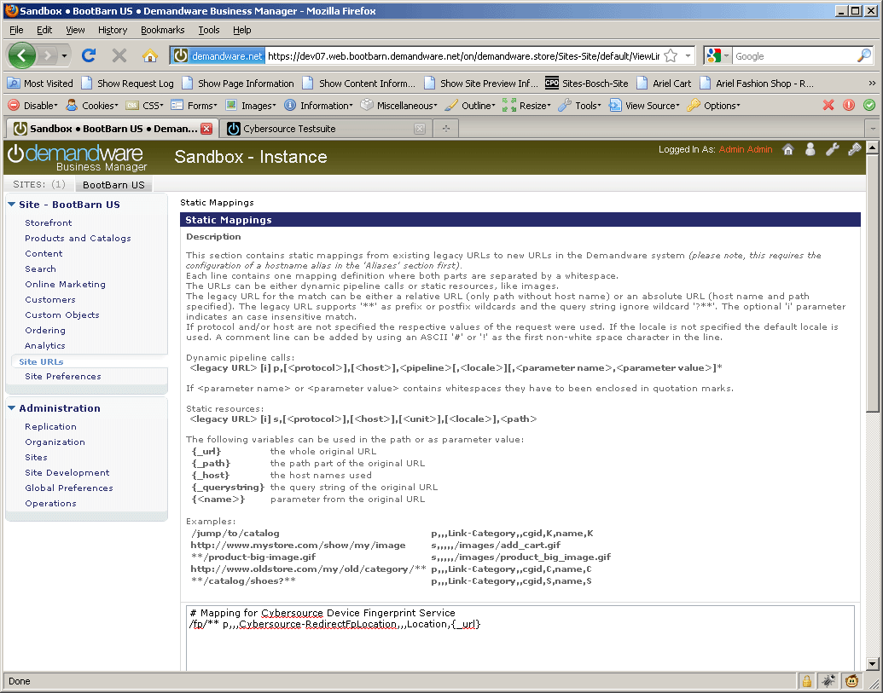
Example for a matching mapping rule for the device fingerprint redirection

Modified Scripts and pipelines for the device fingerprint
Scripts:
libCybersource .ds->addCCAuthRequestInfo modified.
CCAuthRequest.ds (updated WSDL reference)
TestCCAuth (Testcases plus added ‘response object’ dumping for developers)
Pipelines:
CybersourceUnitTesting (new test case)

Known Issues
- In case of setting Ignore AVS Result custom preference to true, there can be a known issue as described below:
If the AVS response code received as N, the cartridge ignores the ccAuthReply reason code and processes the transaction under “review” status. This can lead to an ambiguous situation when the Credit Card was rejected, but due to the AVS code as “N”, the cartridge continued with order processing and successful order placement.

CyberSource document links
- http://www.cybersource.com/support_center/implementation/testing_info/simple_order_api/General_testing_info/soapi_general_test.html
- http://www.cybersource.com/support_center/support_documentation/quick_references/view.php?page_id=422
- http://apps.cybersource.com/library/documentation/dev_guides/CC_Svcs_SO_API/Credit_Cards_SO_API.pdf - Page 163 - Appendix C.
- http://apps.cybersource.com/library/documentation/dev_guides/Getting_Started/Getting_Started_Advanced.pdf
- http://www.cybersource.com/support_center/support_documentation/quick_references/
- http://apps.cybersource.com/library/documentation/dev_guides/Payer_Authentication_IG/20090928_Payauth_IG.pdf
- http://apps.cybersource.com/library/documentation/dev_guides/Payer_Authentication_IG/html/
- http://apps.cybersource.com/library/documentation/dev_guides/CC_Svcs_IG_BML_Supplement/html/
- http://apps.cybersource.com/library/documentation/dev_guides/Verification_Svcs_IG/20091012_Verification_IG.pdf
- http://www.cybersource.com/support_center/support_documentation/services_documentation/tax.php
- http://apps.cybersource.com/library/documentation/dev_guides/Tax_IG/Tax_Guide.pdf
- http://apps.cybersource.com/library/documentation/dev_guides/Retail_SO_API/Retail_SO_API.pdf

Release History
Version | Date | Changes
1.0.0.1 | 02/02/2010 | Initial release
1.0.0.2 | 02/08/2010 | Device Fingerprint Feature added
1.0.0.3 | 03/01/2012 | Updated Tax pipeline to remove unnecessary / redundant tax requests to reduce tax service charges.
1.0.0.4 | 12/18/2012 | Updated Tax pipeline to remove redundant tax requests by using SkipTaxCalculation parameter
1.1.0 | 01/16/2013 | Incorporated review comments from Demandware team
1.1.0 | 02/06/2013 | Incorporated New changes as per new Site Genesis code
2.0.0 | 09/23/2013 | V.me support changes added. Removed deprecated method setGrossPrice for taxation
2.1.0 | 10/04/2013 | V.me Clickjacking changes added
2.1.1 | 11/04/2013 | Removed unsued code from pipeline
2.1.2 | 04/25/2014 | RSA key removed from the cartridge. Bug fixed related to promotional discount.
2.1.3 | 05/29/2014 | Retail Point of Sale (POS) API added

